

AI-Based Crop Recommendation for Farmers
A PROJECT REPORT

Submitted by
PARNIKA RAJGURU - 20221CSE0056
AMOG M - 20221CSE0311
YUKTHI S MOHAN - 20221CSE0479

Under the guidance of,
Mr. Praveen Pawaskar

BACHELOR OF TECHNOLOGY
IN

COMPUTER SCIENCE AND ENGINEERING

PRESIDENCY UNIVERSITY BENGALURU
DECEMBER 2025


PRESIDENCY SCHOOL OF COMPUTER SCIENCE AND ENGINEERING
BONAFIDE CERTIFICATE

Certified that this report “AI-Based Crop Recommendation for Farmers” is a Bonafide work of “PARNIKA RAJGURU (20221CSE0056), AMOG M (20221CSE0311), YUKTHI S MOHAN (20221CSE0479)”, who have successfully carried out the project work and submitted the report for partial fulfilment of the requirements for the award of the degree of BACHELOR OF TECHNOLOGY in COMPUTER SCIENCE ENGINEERING, INTERNET OF THINGS during 2025-26.

Dr. Pamela Vinitha
Project Guide PSCS
Presidency University

Mr. Muthuraju V
Program
Project Coordinator PSCS
Presidency University
Dr Sampath A K Dr. Geetha A School Project Coordinators PSCS
Presidency University

Dr. Blessed Prince
Head of the Department PSCS
Presidency University

Dr. Shakkeera L Associate Dean PSCS
Presidency University

Dr. Duraipandian N
Dean
PSCS & PSIS
Presidency University

Examiners

Sl. No. | Name | Signature | Date
1
2

PRESIDENCY UNIVERSITY

PRESIDENCY SCHOOL OF COMPUTER SCIENCE AND ENGINEERING
DECLARATION

We the students of final year B.Tech in COMPUTER SCIENCE AND ENGINEERING, at Presidency University, Bengaluru, named AMOG M, PARNIKA RAJGURU, YUKTHI S MOHAN hereby declare that the project work titled “AI-Based Crop Recommendation for Farmers” has been independently carried out by us and submitted in partial fulfillment for the award of the degree of B.Tech in COMPUTER SCIENCE AND ENGINEERING during the academic year of 2025-26. Further, the matter embodied in the project has not been submitted previously by anybody for the award of any Degree or Diploma to any other institution.

PARNIKA RAJGURU USN: 20221CSE0056
AMOG M USN: 20221CSE0311
YUKTHI S MOHAN USN: 20221CSE0479

ACKNOWLEDGEMENT
For completing this project work, We/I have received the support and the guidance from many people whom I would like to mention with deep sense of gratitude and indebtedness. We extend our gratitude to our beloved Chancellor, Pro-Vice Chancellor, and Registrar for their support and encouragement in completion of the project.
I would like to sincerely thank my internal guide Mr. Praveen Pawaskar, Eric Professor, Presidency School of Computer Science and Engineering, Presidency University, for his/her moral support, motivation, timely guidance and encouragement provided to us during the period of our project work.
I am also thankful to Dr. Blessed Prince, Professor, Head of the Department, Presidency School of Computer Science and Engineering, Presidency University, for his mentorship and encouragement.
We express our cordial thanks to Dr. Duraipandian N, Dean PSCS & PSIS, Dr. Shakkeera L, Associate Dean, Presidency School of computer Science and Engineering and the Management of. Presidency University for providing the required facilities and intellectually stimulating environment that aided in the completion of my project work.
We are grateful to Dr. Sampath A K, and Dr. Geetha A, PSCS Project Coordinators, Mr. Muthuraju V Program Project Coordinator, Presidency School of Computer Science and Engineering, or facilitating problem statements, coordinating reviews, monitoring progress, and providing their valuable support and guidance.
We are also grateful to Teaching and Non-Teaching staff of Presidency School of Computer Science and Engineering and also staff from other departments who have extended their valuable help and cooperation.
PARNIKA RAJGURU
AMOG M
YUKTHI S MOHAN

Abstract
PRESIDENCY PORTAL Chatbot Based Academic Management System Project Description: The main motive of this project is to create an integrated digital platform that streamline and automate academic activities that are carried out in implementing authority. The purpose of this system is to enhance the management and accessibility of academic resources with an effective interface for both administrators and students.
The system is designed to consist of three main layers: the Frontend Layer, Business Logic Layer and Data Store Layer. The frontend is implemented in React and TailwindCSS for clean, user intuitive view.and responsive interface. The back-end logic, which is written in Node. js and Express. js, processes include: authentication tracking attendance task and video content tasks. Student records, attendance data and other academic information is stored using XML or local storage.
One of the highlights is a student-only chatbot, which was created to help support students' academic and institutional questions. The chatbot has two modes of operation- default mode which responds to queries about institutional data (attendance, assignments, timetables) and It also covers those administrative tasks such as keeping the student's data up-to-date, updating of schedules and monitoring students. By enabling this automation, the portal reduces manual efforts, enhances transparency and promotes instant coordination between students & administrative officials.
In conclusion, the Presidency Portal was developed as a complete digital academic management tool with intelligent interactive learning support media all-in-one. The project falls in line with the current needs of education and also helps in achieving the Sustainable Development Goal (SDG) 4 – Quality Education by providing accessible, technology-based, and efficient educational traffic.

Table of Contents

Sl. No. | Title | Page No.
 | Declaration | III
 | Acknowledgement | IV
 | Abstract | V
 | List of Figures | VIII
 | List of Tables | IX
 | Abbreviations | X
1. | Introduction  - Background  - Statistics  - Prior existing technologies  - Proposed approach  - Objectives  - SDGs  - Overview of project report | 1  1  2  2  3  4  4  6
2. | Literature review | 8
3. | Methodology | 12
4. | Project management  - Project timeline  - Risk analysis  - Resource allocation and team roles | 19  19  20  21
5 | Analysis and Design  - Requirements  - Block Diagram | 23  23  26

 | - System Flow Chart  - Designing Units  - Standards  - Domain Model Specification  - Communication Model  - Functional View  - Operational View  - Other Design | 27  28  30  32  35  37  39  41
6. | Hardware and Software  - Hardware  - Software  - Representation | 42  42  42  44
7. | Evaluation and Results  - Test points  - Test plan  - Test result  - Insights | 47  47  48  49  52
8. | Social, Legal, Ethical, Sustainability and Safety Aspects  - Social Aspects  - Legal Aspects  - Ethical Aspects  - Sustainability Aspects  - Safety Aspects | 53  53  54  55  55  56
9 | Conclusion | 57
 | References | 58
 | Base Paper | 60
 | Appendix | 62

List of Figures

Figure ID | Figure Caption | Page No.
Fig 1.1 | SDG Goals
Fig 5.2.1 | Block Diagram | 26
Fig 5.3.1 | System Flow Diagram | 27
Fig 5.4.1 | Designing Units | 29
Fig 5.5.1 | Standards | 31
Fig 5.6.1 | Domain Model Specification | 34
Fig 5.7.1 | Communication Model | 36
Fig 5.8.1 | Functional View | 39
Fig 5.9.1 | Operational View | 40
Fig 5.10.1 | Other Design | 41
Fig B.1 | Login Page | 63
Fig B.2 | Student Dashboard | 63
Fig B.3 | Admin Dashboard | 64
Fig B.4 | Admin Video Lectures | 64
Fig B.5 | Parental Report | 65
Fig C.1 | XML Storage Layer | 65
Fig C.2 | Dual Authentication System | 66
Fig C.3 | Admin Dashboard Code | 66
Fig D.1 | GitHub Repository | 67
Fig E.1 | Similarity Report | 67
Fig E.2 | AI Report | 68

Table ID | Table Caption | Page No.
Table 2.6.1 | Summary of literature findings | 11
Table 4.1 | Project Phases | 20
Table 4.2 | Identified risks of the project | 21
Table 6.1.1 | Development Environment | 42
Table 6.2.1 | Frontend Tools | 43
Table 6.2.2 | State Management and Data Handling | 43
Table 6.2.3 | Form Handling and Validation | 43
Table 6.2.4 | User Interaction and Feedback | 44
Table 6.3.1 | Representation of Attendance Data | 45
Table 7.3.1 | Student Module | 49
Table 7.3.2 | Attendance Module | 50
Table 7.3.3 | Assignment Module | 50
Table 7.3.4 | Chatbot Module | 51
Table 7.3.5 | Data Persistence | 51

Abbreviation | Full Form
UI | User Interface
UX | User Experience
DB | Database
XML | Extensible Markup Language
CRUD | Create, Read, Update, Delete
API | Application Programming Interface
IDE | Integrated Development Environment
HTML | Hyper Text Markup Language
CSS | Cascading Style Sheet
JS | JavaScript
TS | TypeScript
AI | Artificial Intelligence
IoT | Internet of Things
DBMS | Database Management System
SDG | Sustainable Development Goals
LMS | Learning Management System
CSV | Comma-Separated Values
PDF | Portable Document Format
RAM | Random Access Memory
GPU | Graphic Processing Unit
DOM | Document Object Model
E2E | End-to End (Testing)
RWD | Responsive Web Design
JSON | JavaScript Object Notation
LS | LocalStorage
FPS | Frame Per Second (relevant to video playback)

CHAPTER 1
INTRODUCTION

Agriculture plays a vital role in supporting economies and ensuring food security for a growing global population. However, traditional farming practices often rely on manual observation and experience, which may not always provide accurate decisions regarding crop selection, soil management, or disease control. Farmers frequently face challenges such as unpredictable weather conditions, declining soil fertility, inefficient fertilizer usage, and the spread of crop diseases, all of which can significantly reduce agricultural productivity. These issues highlight the need for modern technological solutions that can assist farmers in making informed decisions. The “AI-Based Crop Recommendation for Farmers” project addresses these challenges by integrating artificial intelligence with a web-based platform designed specifically for farmers. The system allows users to log in and access multiple intelligent features such as crop recommendation based on soil parameters (N, P, K, pH, temperature, and humidity), crop disease detection using image analysis, and a fertilizer calculator that suggests optimal nutrient usage. By analyzing environmental and soil data, the system recommends the most suitable crops for cultivation, helping farmers improve yield and resource efficiency. Additionally, the disease detection module assists farmers in identifying plant diseases early through uploaded images, enabling timely action. Overall, this platform aims to support smarter, data-driven farming practices and promote sustainable agricultural productivity.

Background
Agriculture has always been a fundamental sector that supports food production, economic stability, and the livelihoods of millions of farmers worldwide. However, traditional farming methods often rely on manual knowledge and experience, which may not always provide accurate results in changing environmental conditions. Factors such as soil nutrient imbalance, climate variability, improper crop selection, and plant diseases can significantly reduce crop productivity and farmer income. In recent years, advancements in technologies such as Artificial Intelligence (AI) and machine learning have opened new opportunities for improving agricultural practices. These technologies enable data-driven decision-making by analyzing parameters like soil nutrients, temperature, humidity, and pH levels to recommend suitable crops and detect diseases early. Such intelligent systems help farmers optimize resources, improve crop yield, and adopt more sustainable farming practices.

Statistics of Project
The AI-Based Crop Recommendation for Farmers project is designed as a smart web-based platform that integrates artificial intelligence with agricultural data to assist farmers in making informed decisions. The system analyzes key soil and environmental parameters such as Nitrogen (N), Phosphorus (P), Potassium (K), pH level, temperature, humidity, and rainfall to recommend the most suitable crops for cultivation. A machine learning model trained on agricultural datasets processes these parameters and predicts crop suitability with high accuracy. In addition, the platform includes a fertilizer calculator that uses the same soil parameters to estimate the required nutrient balance for better crop productivity. By converting raw soil data into actionable insights, the system helps farmers improve yield while reducing unnecessary fertilizer usage and costs.

Another important component of the project is the crop disease detection module, which uses deep learning and image processing techniques to identify plant diseases from uploaded images. Farmers can capture or upload an image of a crop leaf, and the trained model analyzes visual patterns to detect possible diseases and provide recommendations. Early detection allows farmers to take timely preventive actions, reducing crop loss and improving farm management. The system architecture also supports real-time data handling and scalable processing, allowing it to analyze multiple user inputs efficiently. These features collectively create a data-driven decision support system for modern agriculture.

To ensure accessibility for farmers from different regions, the platform provides a multi-language user interface that can be switched between English, Kannada, Tamil, and Hindi. This feature makes the system easier to use for farmers who may not be comfortable with English-based applications. The website also includes a secure login system for farmers and a simple dashboard where users can access crop recommendation, disease detection, and fertilizer calculation tools in one place. By combining AI models, a user-friendly interface, and multilingual support, the project aims to bridge the gap between advanced agricultural technology and practical farming needs.

Prior Existing Technologies

Prior to the emergence of this project, farmers primarily depended on traditional farming practices and basic technological tools for decision-making:
• Crop selection was largely based on farmers’ experience, local knowledge, or general seasonal practices rather than scientific analysis of soil nutrients.
• Soil testing results were often provided in printed reports or simple spreadsheets, requiring farmers to interpret values such as Nitrogen (N), Phosphorus (P), Potassium (K), and pH manually without intelligent recommendations.
• Disease identification was mostly performed through visual inspection by farmers or agricultural experts, which could lead to delayed or incorrect diagnosis.
• Some agricultural advisory platforms and mobile apps provided general crop suggestions, but they were often not personalized based on specific soil parameters or environmental conditions.
• Image-based disease detection tools existed in research environments but were not widely integrated into farmer-friendly web systems.
• Many agricultural information systems were available only in English, making them difficult for farmers from regional backgrounds to use effectively.
These fragmented solutions resulted in limited accessibility, delayed decision-making, and inefficient use of fertilizers and resources. Farmers often lacked a unified platform where soil analysis, crop recommendation, disease detection, and fertilizer guidance could be accessed together.
The need for a simple, intelligent, and farmer-friendly system became evident. This led to the development of an integrated AI-powered web platform that combines machine learning for crop recommendation, deep learning for disease detection, and a fertilizer calculator within a single system. The platform also supports multiple languages such as English, Kannada, Tamil, and Hindi, ensuring better accessibility and usability for farmers across different regions.

Proposed Approach

The proposed system is an AI-powered web-based platform that assists farmers in making better agricultural decisions by combining crop recommendation, crop disease detection, and fertilizer calculation in a single integrated environment. The platform analyzes soil and environmental parameters and provides intelligent suggestions to improve crop yield and farm productivity. Farmers can access the system through a simple login interface and use different tools designed specifically for agricultural decision support.
Key Features of the Approach:
• Farmer Login System: Secure login interface that allows farmers to access personalized agricultural tools and services.
• AI-Based Crop Recommendation: Machine learning algorithms analyze soil parameters such as Nitrogen (N), Phosphorus (P), Potassium (K), pH, temperature, and humidity to recommend the most suitable crops for cultivation.
• Crop Disease Detection: A deep learning image recognition model allows farmers to upload crop images and detect possible plant diseases with suggested remedies.
• Fertilizer Calculator: Provides fertilizer recommendations based on soil nutrient values to maintain optimal soil health and improve crop productivity.
• Multi-Language User Interface: The platform supports multiple languages including English, Kannada, Tamil, and Hindi, enabling farmers from different regions to easily use the system.
• Web-Based Accessibility: The system is accessible through standard web browsers on both desktop and mobile devices, ensuring ease of use in rural areas.
This approach reduces dependence on traditional guess-based farming practices and provides farmers with a data-driven, intelligent decision-support system that is simple, accessible, and scalable for modern agriculture.

Objectives
The primary goals of this project are:
• To develop an AI-based web application that assists farmers in selecting the most suitable crops based on soil and environmental parameters.
• To implement a crop recommendation system using machine learning algorithms that analyze factors such as Nitrogen (N), Phosphorus (P), Potassium (K), pH, temperature, and humidity.
• To build a crop disease detection module using deep learning techniques that allows farmers to upload crop images and identify plant diseases at an early stage.
• To create a fertilizer calculator that provides recommendations on the appropriate nutrient requirements based on soil data.
• To design a simple and user-friendly web interface where farmers can easily access crop recommendations, disease detection, and fertilizer suggestions.
• To provide multi-language support including English, Kannada, Tamil, and Hindi so that farmers from different regions can comfortably use the platform.
• To promote data-driven farming practices that help farmers increase crop yield, reduce resource wastage, and support sustainable agriculture.

Sustainable Development Goals
The proposed AI-Based Crop Recommendation for Farmers system aligns with several United Nations Sustainable Development Goals (SDGs) that focus on sustainable agriculture, technological innovation, and reducing inequalities in access to agricultural knowledge. By integrating artificial intelligence, machine learning, and a multilingual web interface, the system supports farmers in making data-driven decisions for crop cultivation, disease management, and fertilizer usage. The platform aims to enhance agricultural productivity while promoting sustainable farming practices and accessibility for farmers from diverse regions.

SDG 2 : Zero Hunger
The project directly contributes to SDG 2 by supporting farmers in improving crop productivity and ensuring efficient agricultural practices. The AI-based crop recommendation system analyzes soil nutrients such as Nitrogen (N), Phosphorus (P), Potassium (K), pH, temperature, and humidity to suggest suitable crops for cultivation. By helping farmers choose the right crops and detect diseases early, the system reduces crop losses and increases yield. This ultimately contributes to improved food production, sustainable agriculture, and enhanced food security.

SDG 9 : Industry, Innovation, and Infrastructure
The project promotes innovation in agriculture by integrating artificial intelligence, machine learning, and deep learning technologies into a web-based farming support platform. The system introduces digital infrastructure that allows farmers to access crop recommendations, disease detection, and fertilizer calculations through a simple website. By leveraging modern technologies, the platform encourages the adoption of smart farming practices, improving efficiency and supporting technological advancement in the agricultural sector.

SDG 10 : Reduced Inequalities
The platform addresses accessibility challenges by providing a multi-language user interface that supports English, Kannada, Tamil, and Hindi, making the system easier to use for farmers from different linguistic backgrounds. This helps bridge the knowledge gap between technologically advanced farming systems and rural farmers who may have limited exposure to digital tools. By making agricultural intelligence accessible to a wider population, the project promotes equal opportunities and reduces technological inequalities in rural communities.

SDG 12: Responsible Consumption and Production
The system supports responsible agricultural practices by recommending appropriate fertilizer usage through the fertilizer calculator. By analyzing soil nutrient data, the platform helps farmers apply fertilizers more efficiently, reducing excessive chemical usage and minimizing environmental impact. This promotes sustainable soil management, conserves natural resources, and encourages environmentally responsible farming practices aligned with SDG 12.

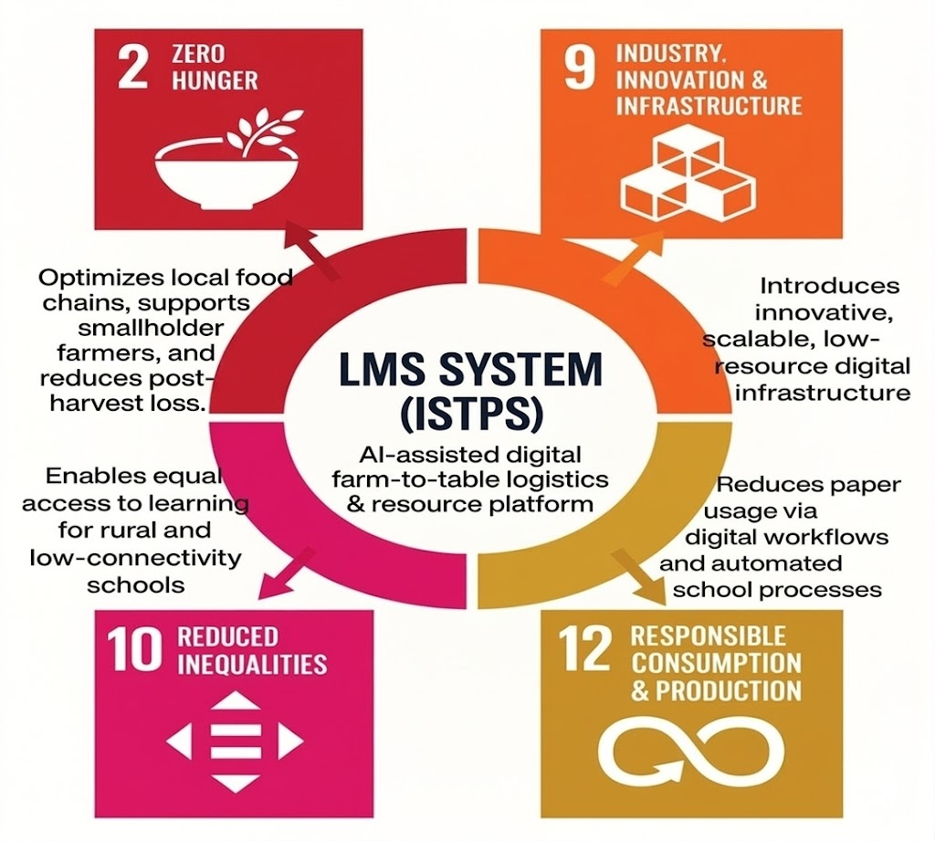

Fig 1.1 SDG Goals

Overview of Project Report
This report provides a detailed account of the planning, design, development, and evaluation of the Interactive Software Tool for Primary School Students.
The chapters are structured as follows:
    - Chapter 1 introduces the background, objectives, and alignment with SDGs.
    - Chapter 2 presents a literature review on related educational technologies.
    - Chapter 3 explains the methodology followed for system design and development.
    - Chapter 4 discusses project management, timeline, risk, and budget planning.
    - Chapter 5 focuses on system analysis and design, including diagrams and models.

    - Chapter 6 elaborates on hardware, software, and implementation details.
    - Chapter 7 provides evaluation and test results.
    - Chapter 8 highlights the social, legal, and ethical aspects of the project.
    - Chapter 9 concludes the report with final insights and future enhancements.

CHAPTER 2
Literature Review

A literature review is an analysis of previous studies and research related to the topic under investigation. In this project, the focus is on AI-based crop recommendation systems, crop disease detection using deep learning, and smart agriculture platforms. The review includes research papers, technological frameworks, and intelligent agricultural systems that apply machine learning, deep learning, and data-driven analytics to improve farming productivity. The aim of this review is to understand existing solutions, identify their limitations, and highlight how the proposed AI-Based Crop Recommendation for Farmers system provides a more integrated and accessible approach for farmers.

Evolution of Smart Agriculture Systems
The adoption of digital technologies in agriculture has significantly increased in recent years as farmers seek efficient methods to improve productivity and resource management. According to Hasan et al. (2022), the integration of Artificial Intelligence (AI), Internet of Things (IoT), and data analytics has transformed traditional agriculture into precision farming by enabling data-driven decision-making. These technologies help farmers monitor soil conditions, weather patterns, and crop health more accurately.

Similarly, Bassine et al. (2023) emphasized that machine learning models can analyze large agricultural datasets to predict crop yield and recommend appropriate farming practices. Platforms using predictive analytics allow farmers to determine the most suitable crops based on environmental and soil conditions.

Despite these advancements, many existing agricultural systems require specialized hardware or IoT infrastructure, which can be costly and difficult to deploy for small-scale farmers. The proposed AI-Based Crop Recommendation System addresses this limitation by providing a web-based platform that allows farmers to input soil parameters and receive crop recommendations without requiring expensive hardware infrastructure.

Crop Recommendation Systems
Crop recommendation systems have become an important research area in precision agriculture. These systems analyze soil nutrients, environmental parameters, and climatic conditions to determine the most suitable crop for cultivation. Research by Rahman (2024) introduced an AIoT-based hydroponic system that collects environmental data and uses machine learning models to recommend crops.

Similarly, several studies have demonstrated that machine learning algorithms such as decision trees, regression models, and neural networks can effectively predict crop suitability based on soil nutrient levels such as nitrogen, phosphorus, potassium, and pH values.
However, many of these systems are designed for research environments or require complex sensor networks, making them less accessible to farmers in rural areas. The proposed system simplifies this process by allowing farmers to manually enter soil parameters and receive AI-based crop recommendations through a simple web interface. This approach ensures accessibility and ease of use for farmers who may not have access to advanced agricultural technology.

Crop Disease Detection Using Deep Learning
Crop diseases are one of the major causes of agricultural losses worldwide. Early detection of plant diseases can significantly reduce crop damage and improve productivity. Recent research has shown that deep learning models, particularly Convolutional Neural Networks (CNNs), are highly effective in identifying plant diseases through image analysis.

Bezabh (2024) developed an ensemble CNN model for mango disease classification, demonstrating high accuracy in detecting plant diseases from leaf images. Similarly, Javidan (2024) discussed how feature engineering and image processing techniques can improve disease detection models even when datasets are limited.

Although these systems show promising results, many are designed for laboratory environments and lack user-friendly interfaces for farmers. The proposed system integrates a web-based image upload feature where farmers can upload crop images to detect diseases using trained deep learning models. This provides a practical and accessible solution for farmers to identify crop diseases early.

Integration of Chatbots in Education
Artificial Intelligence has become a key technology in modern agriculture by enabling predictive analytics, automation, and intelligent decision-making. According to Ghazal (2024), AI-powered computer vision and machine learning techniques are widely used for tasks such as crop monitoring, disease detection, and yield prediction.

AI systems analyze large volumes of agricultural data to identify patterns and generate insights that help farmers optimize resources such as water, fertilizers, and pesticides. This helps improve crop yield while reducing environmental impact.

However, many AI-based agricultural systems require technical expertise and complex deployment processes, which can limit adoption among farmers. The proposed system focuses on providing a simple and intuitive interface that allows farmers to access AI-powered recommendations without requiring technical knowledge.

User Interface and Accessibility in Agricultural Systems
One of the major challenges in implementing smart agriculture systems is ensuring that the technology is accessible and easy to use for farmers. Research on agricultural technology adoption suggests that user-friendly interfaces and localized language support are essential for increasing adoption among rural farmers.

Many existing agricultural applications are designed primarily in English, which may create barriers for farmers who speak regional languages. The proposed system addresses this issue by providing a multi-language user interface that supports English, Kannada, Tamil, and Hindi. This enables farmers from different linguistic backgrounds to use the platform comfortably.

In addition, the web-based design ensures accessibility across various devices such as smartphones, tablets, and desktop computers. By combining a simple interface with multilingual support, the system aims to make advanced agricultural technologies more accessible and practical for everyday farming activities.

Summary of Literature Findings
As shown in the Table 2.6.1, the literature review has pointed out a number of important shortcomings of educational software systems,
Table 2.6.1 : Summary of Literature Findings

Observed Limitation | Existing Systems | How This Project Solves It
Lack of a unified agricultural support platform | Separate tools for crop recommendation, disease detection, and fertilizer guidance | Single platform with all features
High dependency on specialized hardware or IoT infrastructure | IoT-based smart farming systems requiring sensors and expensive equipment | Manual soil data input
Limited accessibility due to language barriers | Many agricultural advisory apps available only in English | Multi-language support
Complex interfaces not suitable for farmers with limited technical knowledge | Research-based agricultural systems with complicated dashboards | Simple user-friendly interface
Lack of early disease identification tools for farmers | Manual inspection or expert consultation for disease detection | AI-based disease detection

Chapter 3 Methodology
This section describes the project methodology, system planning, and design approach used for developing the AI-Based Crop Recommendation for Farmers system. The methodology ensures that the system is reliable, easy to use for farmers, and scalable for future improvements. It explains how data collection, model development, system integration, and testing were performed to build an efficient agricultural decision-support platform.

Research and Requirement Gathering
The first step of the methodology involved identifying and analyzing the requirements of the main stakeholders, which include farmers, agricultural experts, and system developers.
The main aims of this phase were:
    - Identifying the agricultural needs of farmers, including crop recommendation, disease detection, and fertilizer guidance.
    - Recognizing constraints such as limited technical knowledge, language barriers, and limited access to advanced agricultural tools.
    - Understanding the challenges faced by farmers in selecting suitable crops, detecting plant diseases early, and managing soil nutrients effectively.
The outcome of this phase was a clear list of functional and non-functional requirements, which formed the foundation for designing and implementing the AI-based system.

Planning and Strategy
After gathering requirements, a development strategy was created to guide the implementation of the system.
- User-Centered Design: The user interface was designed to be simple and intuitive so that farmers with minimal technical experience can easily use the platform.
- Integrated Agricultural Tools: The system combines crop recommendation, crop disease detection, and fertilizer calculation within a single web-based platform.
- Modular Development: The system was divided into modules such as crop recommendation, disease detection, fertilizer calculation, and multilingual user interface.
- Accessible Web Platform: A browser-based platform was chosen so that farmers can access the system using smartphones, tablets, or computers.
- Multi-Language Support: The platform supports English, Kannada, Tamil, and Hindi, ensuring accessibility for farmers from different regions.
A combined Waterfall and Agile development approach was used for building the system.
• Waterfall Elements: Requirement analysis, planning, and system design were structured in sequential stages to ensure clear project milestones.
• Agile Elements: Iterative development and testing were used during model development and interface design to allow continuous improvements based on feedback.
This hybrid approach ensured proper planning while allowing flexibility for improving AI models and system usability.

System Design and Module Planning
After the planning phase, the system architecture was divided into four major modules.
• User Authentication Module: Provides login functionality for farmers to securely access the platform.
• Crop Recommendation Module: Uses machine learning algorithms to recommend suitable crops based on soil parameters such as Nitrogen (N), Phosphorus (P), Potassium (K), pH, temperature, and humidity.
• Crop Disease Detection Module: Uses deep learning models to analyze images uploaded by farmers and detect plant diseases.
• Fertilizer Calculator Module: Provides fertilizer recommendations based on soil nutrient values to maintain soil fertility and improve crop productivity.
All modules were designed independently but integrated within a single web platform for seamless operation.

Testing and Integration

Multiple testing techniques were applied during the development process to ensure system reliability.
• Functional Testing:
Verified that each module (crop recommendation, disease detection, and fertilizer calculator) performs its intended functions correctly.
• Usability Testing:
Focused on ensuring the interface is simple and understandable for farmers.
• Model Validation:
Machine learning and deep learning models were evaluated for accuracy using agricultural datasets.
• Iterative Feedback:
Improvements were made based on feedback during testing to enhance system performance and usability.
The testing process ensured that the final system provides accurate recommendations and a smooth user experience.

Documentation and Maintenance Strategy

A well-structured documentation and maintenance plan is essential for ensuring the long-term sustainability, usability, and scalability of the AI-Based Crop Recommendation for Farmers system. The platform integrates crop recommendation, crop disease detection, and fertilizer calculation features within a web-based interface designed for farmers. This section outlines the strategy adopted to maintain technical clarity, support future development, and ensure a reliable user experience for farmers and system administrators.

Documentation Strategy
An effective documentation strategy is necessary to maintain clarity regarding the system’s architecture, features, and future development possibilities. Proper documentation ensures that developers, administrators, and future researchers can easily understand the structure and functioning of the system. The documentation also helps maintain system transparency and improves the ease of upgrading or extending system capabilities.

System Documentation

System documentation provides a comprehensive technical description of the system architecture, components, and data flow:

Architecture Documentation:
A detailed overview of the system architecture is maintained. The documentation describes the frontend web application used by farmers, the machine learning models responsible for crop recommendation and disease detection, and the backend components responsible for data processing. Block diagrams and flowcharts are included to illustrate the interaction between modules such as soil parameter input, crop prediction, disease detection, and fertilizer calculation.

Model Documentation:
Documentation of the machine learning and deep learning models used in the system is maintained. This includes information about the algorithms used for crop recommendation, model training procedures, dataset details, evaluation metrics, and prediction accuracy.

Dataset Documentation:
Information regarding datasets used for training and testing the models is recorded. This includes details about soil parameter datasets used for crop prediction and image datasets used for crop disease detection.

User Interface Documentation:
Screens, navigation flows, input forms, and result dashboards are documented using screenshots or wireframes. This ensures that future developers understand how users interact with the platform.

User Documentation

User documentation is created primarily for farmers who will use the system regularly. Since many users may have limited technical experience, the documentation focuses on simplicity and clarity.
- User Manuals

Step-by-step instructions explaining how farmers can log in to the system, enter soil parameters such as nitrogen, phosphorus, potassium, pH, temperature, and humidity, upload crop images for disease detection, and obtain fertilizer recommendations.
- Quick Start Guide

A simplified guide that helps users quickly understand the key functions of the system. The guide uses simple language and clear instructions to assist farmers in accessing the system features easily.
- Language Support Guide

Instructions explaining how farmers can switch the platform interface between supported languages such as English, Kannada, Tamil, and Hindi, ensuring better accessibility.
- FAQ Section
The FAQ section addresses common issues such as incorrect parameter input, image upload problems, or troubleshooting basic system usage.

Developer Documentation

Developer documentation supports smooth system maintenance and future development by providing detailed technical guidance:
- Codebase Documentation The code structure is documented with proper comments, clear folder organization, and explanations of modules responsible for crop prediction, disease detection, and fertilizer calculation.
- Setup & Deployment Guide: Instructions are provided for installing required software libraries, configuring development environments, loading datasets, and running the system locally or on a server.
- Version Control Notes: Git is used to track code updates and maintain a history of system changes. Documentation includes information about branching strategies and release versions to ensure efficient collaboration between developers.

Maintenance Strategy
Since the platform is designed to assist farmers in making agricultural decisions regularly, continuous maintenance is necessary to ensure system reliability, performance, and adaptability to future requirements.
  - Corrective maintenance
Corrective Maintenance focuses on identifying and fixing issues discovered after system deployment:
- Fixing incorrect crop prediction outputs
- Resolving errors in image upload or disease detection
- Correcting login or authentication issues.
- Fixing broken interface components or navigation problems.
  - Adaptive Maintenance
Adaptive maintenance involves updating the system to meet evolving agricultural requirements and technological changes:
- Adding support for new crops and soil parameter datasets
- Updating machine learning models with improved training data
- Accommodating new classrooms or changes to the academic year
- Expanding language support to include additional regional languages

Perfective Maintenance
Perfective maintenance focuses on improving system performance, usability, and accuracy beyond the original system design:
- Optimizing machine learning models to improve prediction accuracy.

- Improving the user interface to simplify data input for farmers.
- Enhancing visualization of recommendations and results.

- Adding new features such as weather-based crop suggestions or pest alerts.

Preventive Maintenance

Preventive maintenance ensures long-term stability and reliability of the system:
- Updating machine learning libraries and dependencies
- Updating machine learning libraries and dependencies

- Performing regular backups of datasets and trained models
- Removing outdated data or unused system files

- Conducting security checks to prevent vulnerabilities

Maintenance Documentation
System documentation is treated as a living document that evolves with the project
- Model documentation is updated.
- Interface screenshots and user guides are revised

- Version notes are recorded to reflect changes
- Dataset or model updates are documented.
This ensures long-term traceability and enables future developers or research teams to extend the system effectivel.

Tools and Techniques Overview
The development of the AI-Based Crop Recommendation for Farmers system followed a structured and disciplined methodology. Several tools and techniques were used to organize the development process and ensure smooth implementation.

Planning and Design Tools

  - Flowcharts: Used to represent system processes such as crop recommendation workflow, disease detection steps, and fertilizer calculation procedures.

  - Block Diagram: Used to illustrate the overall architecture of the system, including data input, machine learning processing, and output generation.

  - System Mockups: Created to visualize the layout of the web interface and ensure that the final design remains simple and user-friendly for farmers.

Version Control and Iterative Development
  - Version Control (Git): Git was used to track code changes and manage collaborative development. It helped maintain system stability while enabling continuous improvements.
  - Iterative Development: The system was developed in incremental stages where each module crop recommendation, disease detection, and fertilizer calculation was implemented, tested, and improved before final integration.

Feedback – Driven Refinement
  - Simulated User Testing: Test users evaluated the platform to identify usability challenges and potential improvements.
  - Feedback Cycle: Continuous improvements were made based on user feedback to enhance accuracy, accessibility, and user experience.

Systematic Transparent and Adaptive Approach
  - The development process followed a structured methodology to ensure that each stage of the project was clearly defined and properly executed.
  - Progress was regularly monitored to ensure that system objectives were achieved.

Chapter 4
Project Management

Effective project management played an important role in the development of the AI-Based Crop Recommendation for Farmers system. Proper planning, coordination, and supervision ensured that the project objectives were achieved within the scheduled timeline while maintaining system quality and reliability. The process included task planning, resource allocation, model development, system integration, and testing. Each stage was organized to successfully implement crop recommendation, disease detection, fertilizer calculation, and multilingual support. Continuous monitoring and evaluation ensured that the system remained reliable, efficient, and user-friendly for farmers.

Project Timeline and Phases
The project spanned a total of sixteen weeks and was divided into separate phases to allow for orderly completion. Refer to Table 4.1 for the detailed breakdown.

Project Phases:
Milestone Highlights
    - Week 2: Finalization of system requirements and identification of necessary datasets for crop recommendation and disease detection.

    - Week 4: Completion of system architecture design and development of user interface mockups.
    - Week 8: Development of prototype modules for crop recommendation and fertilizer calculator.

    - Week 10: Integration of crop disease detection model and implementation of multilingual interface support.
    - Week 13 : Iterative testing, system optimization, and bug fixing to improve system reliability.
    - Week 16 : Final system deployment and preparation for project demonstration.
The structured timeline enabled efficient monitoring of project progress and ensured that each development stage was completed systematically.

Risk Analysis and Management
As indicated in Table 4.2 , Risk management is one of the most important aspects of project management. For this project, potential risks were assessed by their probability, effect and possible mitigation.
Table 4.1 Project Phases

Phase | Duration  (in weeks) | Key Activities | Milestone/Deliverables
Requirement Analysis | 1-2 | Identifying farmer needs, studying crop datasets, analyzing soil parameters and agricultural problems | Requirement Specification  Document
System Design | 3-4 | Designing system architecture, UI layout, model workflow, and database structure | System Design Document
Development (Core Modules) | 5-8 | Implementation of crop recommendation model, fertilizer calculator, user login system, and multilingual interface | Working Prototype of Admin & Student Portals
Chatbot Development | 9-10 | Development and integration of deep learning model for crop disease detection using image input | Fully Functional Chatbot
Testing & Iteration | 11-13 | Unit testing, integration testing, model accuracy and  system testing | Tested & Refined Module
Deployment  Preparation | 14 | Dataset validation, system optimization, interface responsiveness testing | Ready-to-Deploy System
Final Evaluation & Documentation | 15-16 | Preparing project report, documentation, and system demonstration setup | Complete Project Report & Demo

Table 4.2 Identified Risks

Risk | Impact | Likelihood | Mitigation Strategy
Incorrect crop prediction due to poor data quality | High | Medium | Use verified agricultural datasets and perform model validation
Inaccurate disease detection results | High | Medium | Improve model training with larger  image datasets and continuous testing
Integration issues between modules | Medium | Medium | Continuous integration testing after each development phase
Interface complexity for farmers | Medium | Low | Design a simple UI and perform usability testing
Time overrun | Medium | Low | Follow project timeline and conduct regular progress reviews

Risk Mitigation Strategies

    - Proactive Testing: Unit testing and integration testing were conducted regularly to ensure that modules such as crop recommendation, disease detection, and fertilizer calculation functioned correctly.
    - Iterative Feedback: Feedback from test users and simulated farmers helped identify usability issues and improve system accuracy.
    - Structured Backups: Regular backups of datasets, trained models, and source code were maintained to prevent data loss.
    - Monitoring & Reporting: Weekly progress reviews helped identify potential issues early and ensured that the project remained on schedule.
Efficient management of time and resources allowed the project to progress smoothly from one milestone to the next..

Resource Allocation and Team Roles
While this project was primarily developed individually, careful planning of time, tools, and technical resources was essential for successful implementation.
    - Time Allocation: Tasks were divided into weekly targets to ensure systematic progress in stages such as data collection, model development, system integration, and testing.
    - Human Resource Management: Responsibilities included:
      - Project Planning & Design: Requirement analysis, system architecture design, flowcharts, and user interface planning.
      - Development: Implementation of crop recommendation model, disease detection module, fertilizer calculator, and multilingual interface.
      - Testing & Feedback: Model evaluation, system testing, bug tracking, and refinement of features based on feedback.
      - Documentation: Preparation of project reports, system diagrams, technical documentation, and presentation materials.

Quality Assurance

    - Quality assurance practices were incorporated throughout the project to ensure reliability, accuracy, and usability of the system.
    - Module Testing: Individual modules such as crop recommendation, disease detection, and fertilizer calculation were tested independently to verify their functionality.
    - Integration Testing: Different modules were integrated and tested together to ensure smooth interaction and proper system workflow.
    - Usability Testing: Test users evaluated the system interface to ensure that farmers could easily input soil data, upload crop images, and understand recommendations.
    - Bug Tracking: Identified errors and issues were documented and resolved through iterative testing and improvements
    - Performance Testing: The system was tested to ensure fast response times, accurate predictions, and smooth performance across different devices and web browsers.

Chapter 5 Analysis and Design

Requirements
Before the design and development of the AI-Based Crop Recommendation for Farmers system, a detailed analysis of system requirements was conducted. The main objective of this phase was to identify the key functional and non-functional requirements of the system while considering user needs and technical limitations. These requirements were gathered through research on smart agriculture systems, analysis of agricultural datasets, and understanding the challenges faced by farmers in crop selection, disease identification, and soil nutrient management. The analysis helped define the system features such as crop recommendation, crop disease detection, fertilizer calculation, and multilingual support. The identified requirements served as the foundation for designing the system architecture and implementing the platform effectively.

Functional Requirements
Functional requirements describe the specific operations and feature that the system must perform to achieve its objectives. The AI-Based Crop Recommendation for Farmers system is designed to support farmers by providing intelligent agricultural recommendations and tools.

User Authentication and Access Control
          - Farmers must be able to securely log in to the platform.
          - The system should provide a secure authentication mechanism to protect user data.

Crop Recommendation System
          - Farmers can input soil parameters such as Nitrogen (N), Phosphorus (P), Potassium (K), pH level, temperature, and humidity.
          - The machine learning model analyzes these inputs and recommends suitable crops for cultivations.

Crop Disease Detection
          - Farmers can upload images of crop leaves through the platform.
          - The deep learning model analyzes the uploaded images to detect possible plant diseases and provide suggestions.

Fertilizer Recommendation
          - Based on soil nutrient values, the system provides fertilizer recommendations to improve soil fertility.

          - The system helps farmers maintain the correct nutrient balance for better crop productivity.

Multi-Language User Interface
          - The platform allows users to switch the interface between English, Kannada, Tamil, and Hindi.
          - This ensures better accessibility for farmers from different regions.

Data Input and Processing
          - Farmers can manually input soil parameters through a simple form interface.
          - The system processes the input data using machine learning models to generate recommendations.

Dashboard and Results Display
          - The system provides a clear dashboard showing crop recommendations, detected diseases, and fertilizer suggestions.
          - Results are displayed in a simple and understandable format for farmers.

Dashboard and Notifications
          - Centralized dashboard for real-time updates.
          - Notifications for generated outputs.

Non-Functional Requirements
Non-functional requirements describe the quality attributes of the system such as usability, performance, security, and reliability. These requirements ensure that the system operates efficiently and provides a positive user experience.

Usability
- The interface must be simple and easy to use for farmers with limited technical knowledge.

- The design should include clear input forms, readable text, and straightforward navigation.

Performance
- The system should generate crop recommendations and disease detection results within a few seconds.
- The platform should maintain fast response times under normal usage conditions.

Scalability
- The system should support additional crops, datasets, and new features in the future.

- The architecture should allow integration with mobile applications or IoT-based data sources.

Security
- Secure login mechanisms must protect user accounts.
- Sensitive user data must be handled securely to prevent unauthorized access.

Maintainability
- The system should follow a modular architecture so that modules such as crop recommendation or disease detection can be updated independently.
- Proper documentation should be maintained for future upgrades.

Accessibility
- The platform should be accessible through web browsers on desktops and mobile devices.
- Multi-language support ensures that farmers from different linguistic backgrounds can easily use the system.

Block Diagram
As shown in Figure 5.2.1, shows a block diagram that represents the different levels of hierarchy of the Presidency Portal. These are the ‘Frontend Layer’, ‘Application Logic Layer’, and ‘Data Storage Layer’. For the frontend, the functionality is concerned with the user interactions
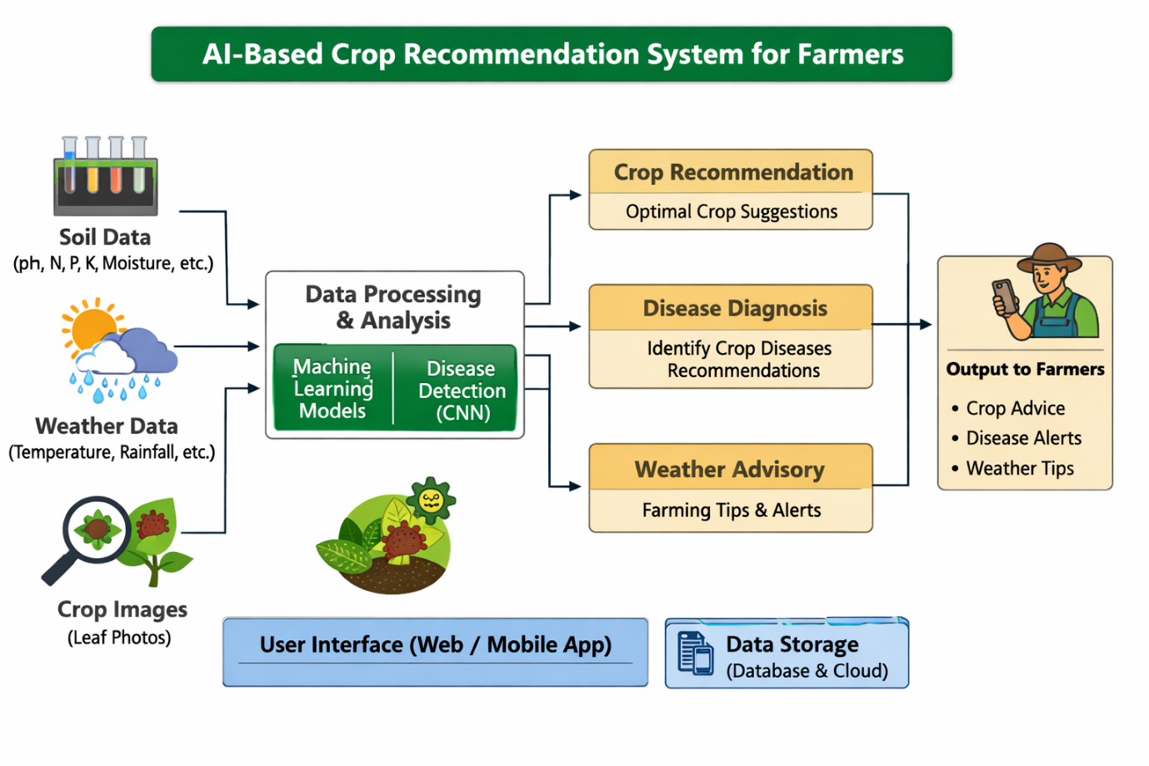
and the admins and students. In the application layer, we have the core logic functionalities that include, among others, the different.

Fig 5.2.1 Block Diagram

System Flow Diagram
As shown in Figure 5.3.1 , System Flow Chart System flow chart presents the sequence of activities performed by student logging to AI Based Crop Recommendation System for Farmers. The system initiates with user login, after which the farmer is directed to the main service modules of the platform.

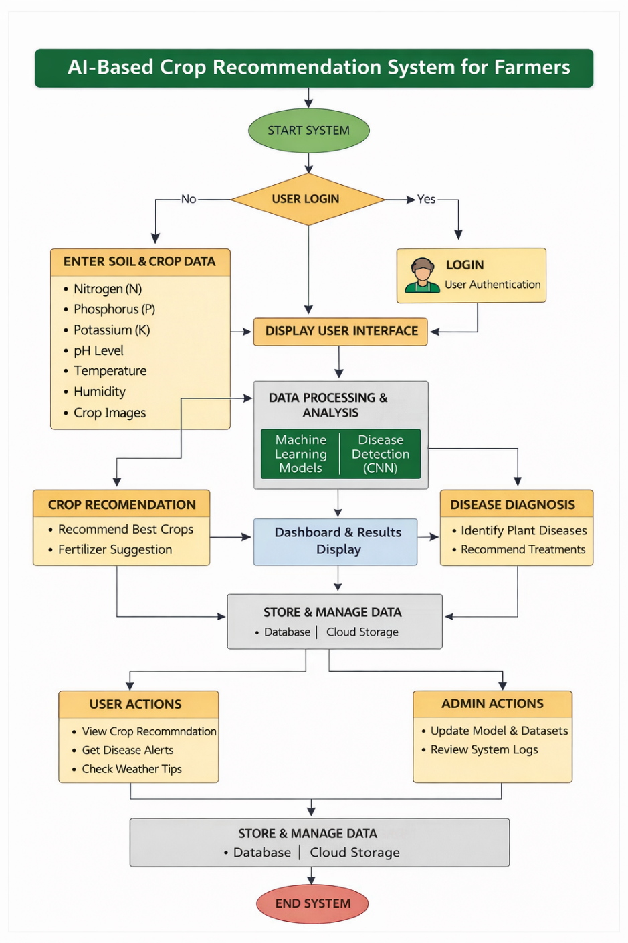

Fig 5.3.1 System Flow Chart

Designing Units
The system is divided into functional units that handle different operations of the AI-Based Crop Recommendation for Farmers platform. This modular design ensures that the system is scalable, maintainable, and efficient (see Fig 5.4.1 for a visual illustration)

Authentication and User Management Unit
  - Handles user login validation for farmers.

  - Ensures secure authentication and session management.

  - Maintains user data for smooth access to system features.

Crop Recommendation Unit
  - Allows farmers to input soil parameters such as Nitrogen (N), Phosphorus (P), Potassium (K), pH, temperature, and humidity.

  - Uses machine learning models to analyze input data.

  - Provides suitable crop recommendations based on soil and environmental conditions.

Crop Disease Detection Unit
  - Enables farmers to upload crop leaf images.

  - Uses deep learning (CNN) models to detect plant diseases.
  - Displays disease name along with suggested remedies.

Fertilizer Recommendation Unit
  - Calculates fertilizer requirements based on soil nutrient values.

  - Suggests appropriate nutrient composition to improve soil fertility.

  - Helps farmers maintain balanced fertilizer usage.

Data Processing and Model Unit
  - Processes input data using machine learning and deep learning models.
  - Handles prediction logic for crop recommendation and disease detection.
  - Ensures accurate and efficient data analysis.

Multi-Language Support Unit
  - Provides language switching options including English, Kannada, Tamil, and Hindi.
  - Ensures better accessibility for farmers from different regions.
  - Displays system outputs in the selected language.

Dashboard and Results Unit
  - Displays crop recommendations, disease detection results, and fertilizer suggestions.
  - Provides a clear and simple interface for farmers to understand results.
  - Organizes outputs in an easy-to-read format.

User Interface and Navigation Unit
  - Provides a clean and user-friendly interface for farmers.
  - Includes simple forms for input and easy navigation between modules.
  - Ensures responsive design for mobile and desktop usage.

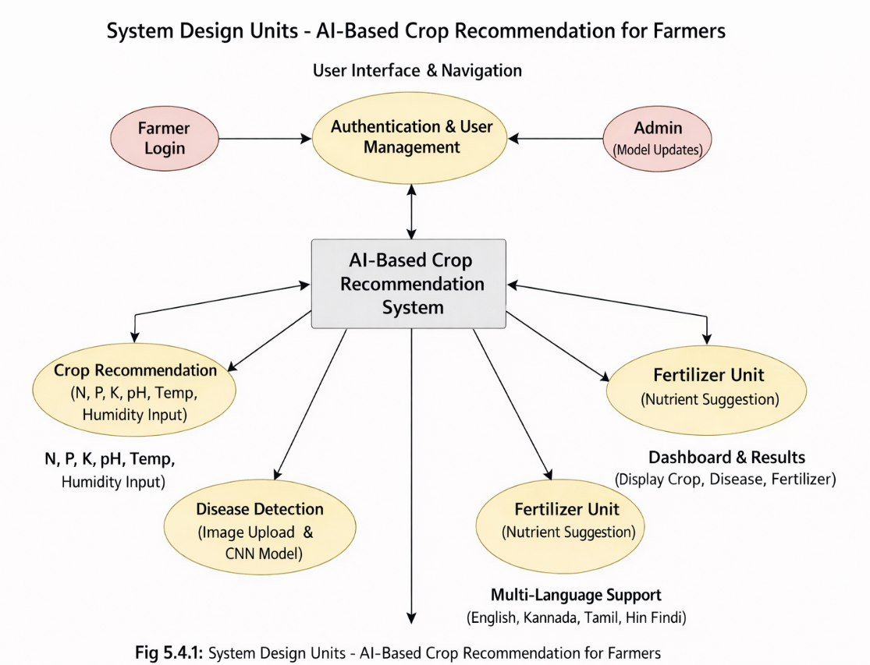
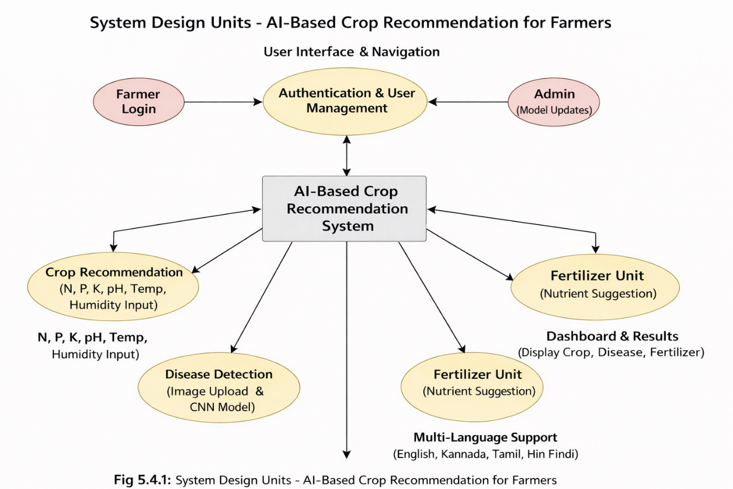
Fig 5.4.1 Designing Units

Standards
Following standard practices ensures that the AI-Based Crop Recommendation for Farmers system is reliable, secure, scalable, and user-friendly. These standards cover software development, data handling, security, user interface design, and testing processes, making the system suitable for real-world agricultural use.

Software Development Standards

        - The system follows a modular architecture, ensuring separation between data processing (models), application logic, and user interface.
        - Standard programming practices using Python for AI models and web technologies (HTML, CSS, JavaScript) ensure maintainability and scalability.
        - The web application is designed to be cross-browser compatible and follows standard web guidelines for responsiveness.

Data Management Standards
        - Structured datasets are used for training machine learning and deep learning models to ensure data accuracy and consistency.
        - Proper data handling techniques are applied to avoid redundancy and maintain data integrity.
        - Input validation ensures that only correct soil parameters and image data are processed by the system.

Security and Privacy Standards
        - The system follows standard security practices to prevent vulnerabilities such as invalid inputs and unauthorized access.
        - User credentials are handled securely using authentication mechanisms.

        - Data transmission and system interaction follow secure practices to protect user information.

User Interface and Accessibility Standards

        - The interface is designed to be simple, clear, and easy to use for farmers with minimal technical knowledge.
        - The system supports multiple languages (English, Kannada, Tamil, Hindi) to improve accessibility.
        - The application is responsive and works efficiently on desktops, tablets, and mobile devices.

Testing and Documentation Standards
        - Unit testing and integration testing are performed to ensure that all modules function correctly.

        - The system is tested for usability, performance, and accuracy of predictions.

        - Proper documentation, including user guides and technical details, is maintained to support future development and maintenance.

Domain Model Specification
The domain model for the AI-Based Crop Recommendation for Farmers system represents the key entities, their attributes, and relationships within the platform. It helps in understanding how different components of the system interact with each other and support overall functionality.

Objectives of Domain Modeling
The domain model functions:

- Represent the core functional areas of the system such as crop recommendation, disease detection, and fertilizer guidance.
- Identify key entities involved in the system and define their relationships.

- Specify attributes of each entity to support system operations and data processing.

Key Entities and Their Descriptions

The domain model consists of the following important entities:

User (Farmer)

  - Represents the primary user of the system.
  - The farmer interacts with the system to input soil data, upload images, and receive recommendations.
  - The farmer interacts with the system to input soil data, upload images, and receive recommendations.

Soil Data

  - Represents the input parameters provided by the farmer.
  - Used for crop recommendation and fertilizer calculation.

Attributes: soil_id, nitrogen (N), phosphorus (P), potassium (K), pH, temperature, humidity
- Crop Recommendation
  - Represents the output generated by the machine learning model.
  - Suggests suitable crops based on soil and environmental data.

Attributes: recommendation_id, soil_id, recommended_crop, confidence_score.

- Disease Detection
  - Represents the disease prediction results from uploaded crop images.
  - Uses deep learning models to identify plant diseases.
  - Attributes: disease_id, image_path, detected_disease, accuracy, suggested_remedy.

- Fertilizer Recommendation
  - Provides fertilizer suggestions based on soil nutrient values.
  - Helps maintain soil fertility and improve crop yield.

Attributes: fertilizer_id, soil_id, recommended_nutrients, quantity.

- Model (AI/ML Model)
  - Represents machine learning and deep learning models used in the system.
  - Responsible for crop prediction and disease detection.

Attributes: model_id, model_type, accuracy, training_data.
- System Dashboard
  - Displays results to the farmer in a user-friendly format.
  - Shows crop recommendations, detected diseases, and fertilizer suggestions.
  - Attributes: dashboard_id, user_id, results_displayed.

Relationships Between Entities

The associations between these entities are seen below:
- User → Soil Data (One-to-Many): A user can input multiple soil data records.

- Soil Data → Crop Recommendation (One-to-One): Each soil data input generates one crop recommendation.
- Soil Data → Fertilizer Recommendation (One-to-One): Each soil data input produces a fertilizer recommendation.
- User → Disease Detection (One-to-Many): A user can upload multiple images for disease detection.

- Disease Detection → Model (Many-to-One): Multiple disease predictions are generated using a single trained model.
- Crop Recommendation → Model (Many-to-One): Multiple recommendations are generated using a trained ML model.
- Class → Assignment (One-Many): An assignment may belong to one or more classes.

- User → Dashboard (One-to-One): Each user has a personalized dashboard displaying results.

Communication Model

The communication model of the AI-Based Crop Recommendation for Farmers system describes how data flows between the user interface, processing components, and data storage/model layers. The system follows a client-server-like architecture, where the web-based frontend interacts with machine learning models and backend logic to process user inputs and generate outputs.

User Interaction Layer (Frontend)
  - Handles the user interface for farmers.
  - Allows users to input soil parameters (N, P, K, pH, temperature, humidity) and upload crop images
  - Displays outputs such as crop recommendations, disease detection results, and fertilizer suggestions.
  - Uses web technologies (HTML, CSS, JavaScript) to capture user inputs and present results.

Processing Layer (Logic Handling)
  - Contains the core logic for handling user requests and generating responses.
  - Machine learning models process soil data for crop recommendation.
  - Deep learning models (CNN) process images for disease detection.
  - Input validation and data formatting are handled before processing.

Data Storage Layer (XML-based Storage)
  - Stores datasets used for training machine learning and deep learning models.
  - Maintains user inputs temporarily during system interaction.
  - Handles retrieval and update of data required for predictions.
  - Acts as the backend layer supporting AI model execution.

Flow of Communication
The communication between different components of the system follows these steps:

      - User Request initiation: When a farmer enters soil data or uploads a crop image, the frontend captures the input and sends a request to the processing layer.
      - Data Processing: The system validates the input data and passes it to the appropriate machine learning or deep learning model.
      - Model Execution / Data Access: The model processes the input data and generates predictions such as crop recommendation, disease detection, or fertilizer suggestions.
      - Response Generation: The results generated by the models are formatted into a response and sent back to the frontend.
      - User Feedback: The frontend displays the results on the dashboard in a clear and user-friendly format.

This continuous flow of communication enables the system to function as an interactive and intelligent agricultural support platform.

5.7.4 Communication Characteristics
The communication model of the system has the following characteristics:

- Bidirectional Data Flow: Data flows between user input and system output continuously.

- Asynchronous Operations: Model execution and response generation occur efficiently without blocking user interaction.

- Event-driven Triggers: User actions such as submitting soil data or uploading images trigger system processing.

5.7.5 Communication Modes
The system supports the following communication modes:

User Interaction Mode (Farmer Mode):
  - Farmers interact with the system by entering soil parameters and uploading crop images.
  - The system processes inputs and provides crop recommendations, disease detection results, and fertilizer suggestions.

System Processing Mode (AI Model Mode):
  - The system internally processes user inputs using machine learning and deep learning models.
  - It retrieves relevant data, performs analysis, and generates accurate outputs.
Additionally, the system dashboard acts as an interactive interface, providing real-time responses and ensuring smooth communication between the user and the system logic.

Functional View
The functional view of the AI-Based Crop Recommendation for Farmers system illustrates how different modules and components work together to deliver intelligent agricultural services. It highlights the interaction between user inputs, processing mechanisms, and output generation to achieve the system’s objectives.

Overview
The system is designed as an integrated web-based platform that assists farmers in making informed agricultural decisions. It combines multiple functionalities such as crop recommendation, crop disease detection, fertilizer calculation, and multilingual support within a single interface. The system is designed as an integrated web-based platform that assists farmers in making informed agricultural decisions. It combines multiple functionalities such as crop recommendation, crop disease detection, fertilizer calculation, and multilingual support within a single interface.

Key Functional Modules

  - Crop Recommendation Module

    - Allows farmers to input soil parameters such as Nitrogen (N), Phosphorus (P), Potassium (K), pH, temperature, and humidity.
    - Uses machine learning algorithms to analyze the input data and recommend suitable crops.

Disease Detection Module

    - Enables farmers to upload images of crop leaves.
    - Helps farmers maintain proper nutrient balance for improved crop yield.

User Interface Module
    - Provides a simple and user-friendly dashboard for farmers.
    - Displays crop recommendations, disease detection results, and fertilizer suggestions clearly.

Functional Flow
  - Input Phase: The farmer enters soil parameters or uploads crop images through the web interface.
  - Processing Phase: The system processes the input data using machine learning and deep learning models to generate predictions.
  - Output Stage: The results, including crop recommendations, detected diseases, and fertilizer suggestions, are displayed on the dashboard in a clear and understandable format.

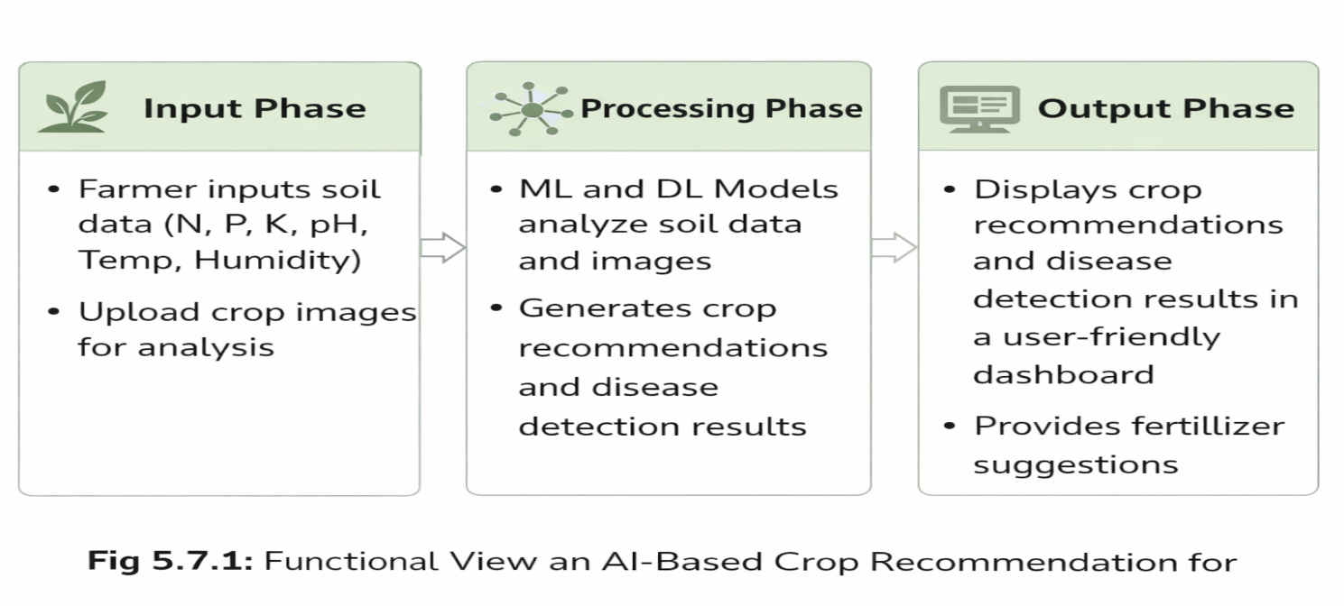
Fig 5.8.1 Functional View

Operational View

This chapter discusses the operation of the presidency portal in real time as users interact with the system fig 5.9.1 below shows how internally to respond to user interaction here are a number of financial and administrative interactions available through this system.

User Roles & Access
  - Students
    - Login via web interface
    - Link features: attendance, timetable, results, chatbot

Administrators/Faculty

    - Manage student records
    - Update courses, announcements
    - Train chatbot modules

Authentication Flow
- Users authenticate through login page

- Credentials verified against centralized storage
- On successful login feature access based on roles is get provided

User Interactions & System Responses

Data retrieval
- Data update
- Validation checks (e.g., login, data input) Real-time feedback is provided via the user interface

Backend Operations
- Ensures data consistency and synchronization

- Manages business logic and data communication

- Communicates with XML-based storage/localStorage
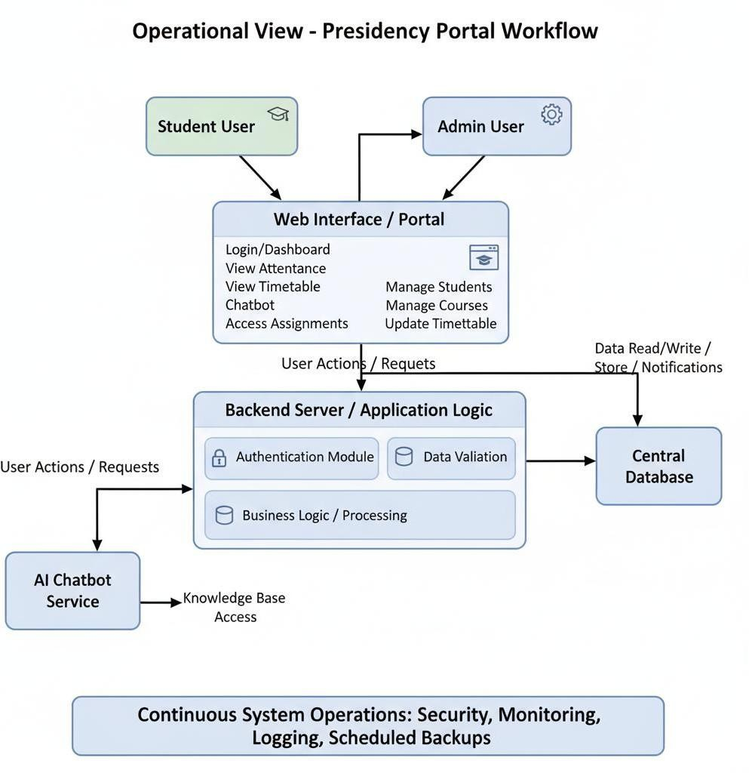

Fig 5.9.1 Operational View

Other Design

Additional design aspects for improved usability, performance and future expandability of the Presidency Portal are presented in details in Fig 5.10.1.
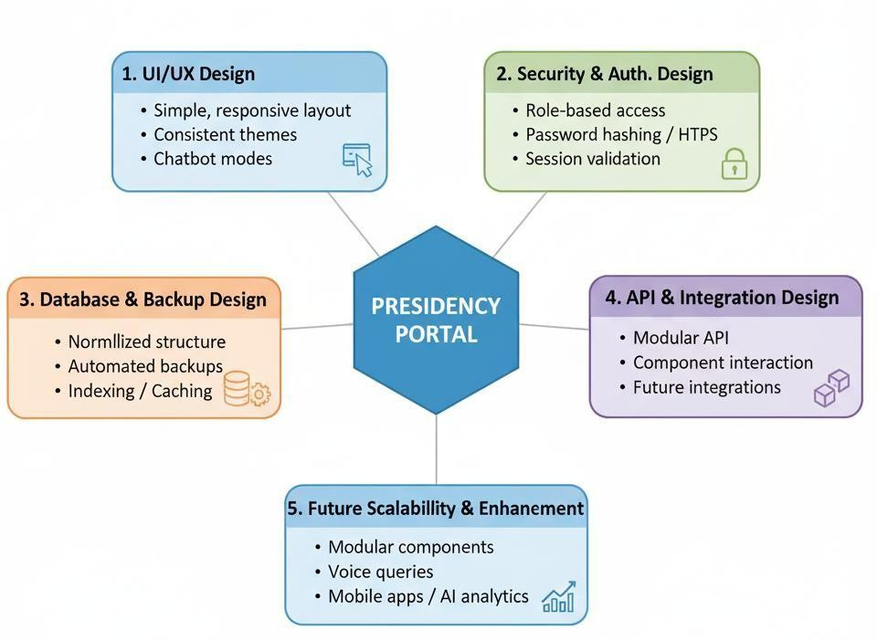
Fig 5.10.1 Other Design

Chapter 6 Hardware And Software
This chapter presents a detailed description of the hardware and software environment used for developing the AI-Based Crop Recommendation for Farmers system. It also explains the data representation and testing procedures used to verify system functionality, evaluate model performance, and ensure system reliability before deployment.

Hardware Requirements
As shown in the Table 6.1, Although the project is primarily a web-based application, certain hardware specifications were necessary for smooth development, machine learning model training, testing, and system execution.

Development Environment
Table 6.1.1 : Development Environment

Component | Specification | Purpose
Processor | Intel Core i5 or higher | Efficient model training, code execution, and multitasking
RAM | 8 GB or higher | Running machine learning models, development tools, and web servers
Storage | 10 MB free space | Storage for datasets, trained models, and project files
Graphics | Integrated or dedicated  GPU | Faster processing for deep learning image classification
Display | Full HD 1920x1080 | Accurate interface testing and responsive UI design
Peripherals | Keyboard, Mouse | Basic input devices for development and testing

  - Software Development Tools
The webdev technologies enable to develop a strong and scalable portal which is also user- friendly. These tools facilitated modular design, testing & seamless integration of interactive

features shown in Table fig 6.2.1

Frontend Tools
Table 6.2.1 Backend and AI Tools

Tool/Technology | Version/Details | Purpose
Python | 3.x | Core programming language for AI model development
Scikit-learn | Scikit-learn | Machine learning algorithms for crop recommendation
TensorFlow / Keras | Latest | Deep learning framework for crop disease detection
OpenCV | Latest | Data manipulation and preprocessing
Pandas | Latest | Accessible and reusable UI components

State Management & Data Handling
Table 6.2.2 : Web Development Tools

Tool/Technology | Purpose
HTML | Structure of the web interface
CSS | Styling and layout of the web application
Flask / Web Framework | Integration between AI models and frontend interface
JavaScript | Interactive web functionality

Form Handling and Validation
Table 6.2.3 : Data Processing Tools

Tool/Technology | Purpose
Jupyter Notebook | Model development and experimentation
Matplotlib / Seaborn | Data visualization and analysis
Kaggle Dataset | Agricultural dataset for crop recommendation and disease detection

6.2.4 Development Workflow
- Version Control: Git was used to manage source code versions and track project progress.
- Testing Tools: Python debugging tools and browser developer tools were used to test the application.
- Model Training Environment: Jupyter Notebook was used for dataset preprocessing, training machine learning models, and evaluating performance.

- Documentation Tools: Markdown editors and diagram tools were used to create system documentation, flowcharts, and architecture diagrams.

Data Representation
Simulation and testing are essential for verifying system functionality, validating predictions, and ensuring reliable interaction between system modules. The complete overview is shown in Table 6.3.1
The system processes two primary types of data:
• Soil parameter data used for crop recommendation
• Image data used for crop disease detection

Soil Data Representation

Farmers provide soil parameters such as nitrogen, phosphorus, potassium, pH level, temperature, and humidity to obtain crop recommendations

Table 6.3.1 : Representation Of Attendance Data

Nitrogen (N) | Phosphorus (P) | Potassium (K) | Temperature | Humidity | pH | Recommended Crop
90 | 43 | 43 | 20.8 | 82 | 6.5 | Rice
85 | 58 | 41 | 26.2 | 60 | 6.7 | Maize

Module Representation
- Crop Recommendation Module:
  - Accepts soil nutrient values from farmers.
  - Processes the data using machine learning algorithms.
  - Displays the most suitable crop recommendations.

Crop Disease Detection Module:
  - Farmers upload crop leaf images through the system.
  - The deep learning model analyzes the image to detect plant diseases.
  - The system provides the disease name and suggested remedies.

Fertilizer Recommendation Module:

Uses soil nutrient data to estimate the required fertilizer composition.

Provides recommendations to maintain soil fertility.

Multi-Language Interface

Allows users to switch between English, Kannada, Tamil, and Hindi.

Ensures accessibility for farmers from different regions.

Testing Workflows
      - Workflow 1 – Crop Recommendation: Farmer enters soil parameters → System processes data → Machine learning model predicts suitable crops → Result displayed on dashboard.
      - Workflow 2 - Assignment Start: Farmer enters soil parameters → System processes data → Machine learning model predicts suitable crops → Result displayed on dashboard.

        - verifies submission → Dashboard reflects completion.
      - Workflow 3 – Fertilizer Recommendation: Farmer inputs soil nutrient values → System calculates fertilizer requirement → Recommendation displayed to the user.
These workflows ensured the correctness of system interactions before deployment.

Performance Evaluation

System performance was evaluated through several tests
      - Verified crop prediction accuracy using agricultural datasets.
      - Tested disease detection accuracy with image datasets.

      - Evaluated system response time for generating recommendations.
      - Tested responsiveness of the web interface across different devices (desktop and mobile).
      - Ensured smooth operation of the multilingual interface for farmers.

Chapter 7 Evaluation and Results
Evaluation and testing were essential to ensure that the AI-Based Crop Recommendation for Farmers system met its functional, usability, and performance requirements. The purpose of this phase was to verify the reliability, accuracy, and user-friendliness of the developed system. Various testing procedures were carried out to examine the behavior of different modules such as crop recommendation, crop disease detection, fertilizer calculation, and the multilingual user interface. The results of these tests confirmed that the system performs efficiently and provides useful recommendations for farmers.

Test Points

The testing process focused on the following major areas to ensure that the system operates effectively and reliably:

User Authentication

- Verification of secure login functionality for farmers
- Validation of user access to system modules after authentication
- Display of recommended crops on the dashboard

Crop Recommendation Module

- Input validation for soil parameters such as Nitrogen (N), Phosphorus (P), Potassium (K), pH, temperature, and humidity
- Verification of machine learning model predictions
- Display of color-coded attendance indicators on dashboards

Crop Disease Detection Module
- Uploading crop leaf images for disease analysis
- Verification of correct disease detection using deep learning models
- Display of disease name and suggested remedies

Fertilizer Recommendation Module

- Calculation of fertilizer requirements based on soil nutrient values
- Verification of accurate nutrient recommendations
- Proper display of fertilizer suggestions to the farmer

Multi-Language Interface

- Switching between supported languages: English, Kannada, Tamil, and Hindi
- Verification that all interface elements are translated correctly
- Testing ease of navigation for users in different languages

Dashboard and Result Display

- Display of crop recommendations and disease detection results
- Clear presentation of information for easy understanding
- Verification of system responses after user input

User Interface & Responsiveness

- Navigation across modules
- Layout consistency on desktop, tablet, and mobile
- Visual feedback (toasts, progress bars, status indicators)

Test Plan
The test plan was designed to evaluate system performance through functional testing, usability testing, and model accuracy validation.

Testing Strategy
      - Functional Testing: Ensured that all modules including crop recommendation, disease detection, and fertilizer calculator operate correctly

      - Performance test: Measured system response time when processing user inputs and generating recommendations
      - Integration Testing: Verified that all modules work together seamlessly within the web platform.

Test Methodology
- Module Testing: Each module was tested individually to verify its functionality.

- End-to-End Workflow Testing: Complete workflows were tested, starting from entering soil data to receiving crop recommendations.
- Simulated User Interactions: Test users simulated farmer interactions such as uploading crop images and entering soil parameters.
- Data Persistent Testing: Input data was verified to ensure accurate processing by the machine learning models

Test Results
Observations produced from the testing of all modules are summarized and presented in tables below.

Crop Recommendation Module
Table 7.3.1 : Crop Recommendation Module

Test Case | Expected Result | Observed Result | Status
Enter soil parameter | System predicts suitable crop | Correct crop recommendation displayed | Pass
Invalid input handling | System validates input values | Input validation working correctly | Pass
Result display | Recommended crop shown clearly | Results displayed properly | Pass
Observation: The machine learning model successfully recommended crops based on soil parameters and environmental conditions.

Disease Detection Module
Table 7.3.2 : Disease Detection Module

Test Case | Expected Result | Observed Result | Status
Upload crop image | Image processed by model | Disease detected successfully | Pass
Disease identification | Correct disease predicted | Accurate results observed | Pass
Result display | Disease and remedy shown | Information displayed correctly | Pass
Observation: The deep learning model was able to detect crop diseases effectively from uploaded images

Fertilizer Recommendation Module
Table 7.3.3 : Fertilizer Recommendation Module

Test Case | Expected Result | Observed Result | Status
Enter soil nutrient values | Fertilizer recommendation generated | Correct nutrient suggestion displayed | Pass
Nutrient calculation | Balanced fertilizer values shown | Balanced fertilizer values shown | Pass
Display results | Clear fertilizer guidance | Displayed correctly | Pass
Observation: The fertilizer calculator provided accurate nutrient recommendations based on soil input data

Multi-Language Interface
.
Test Case | Expected Result | Observed Result | Status
Language switch | Interface language changes | Successfully switched languages | Pass
Content translation | All elements translated correctly | Verified for all languages | Pass
Navigation in different languages | Smooth interface usage | No errors found | Pass
Observation: The deep learning model was able to detect crop diseases effectively from uploaded images.

User Interface and Responsiveness
Table 7.3.4 : User Interface Module

Feature | Test Case | Observed Result | Status
Crop Recommendation Interface | Enter soil parameters and submit | Recommendation displayed clearly | Pass
Disease Detection Interface | Upload crop leaf image | Image processed and disease result shown | Pass
Language Switching | Change interface language | Successfully switched between English, Kannada, Tamil, Hindi | Pass
Navigation | Move between modules | Smooth navigation across all pages | Pass
Observation: The user interface was simple and responsive. Farmers could easily navigate between modules, enter soil data, upload images, and view results. The multilingual interface worked correctly without any usability issues.

Data Processing and Persistence
Table 7.3.5 : Data Persistence

Test Case | Expected Result | Observed Result | Status
Soil data input | System processes input values | Correct crop recommendation generated | Pass
Fertilizer calculation | Nutrient requirement calculated | Accurate fertilizer recommendation shown
Image upload | Image processed by model | Disease detection results displayed | Pass
Observation: The system successfully processed user inputs and generated accurate outputs for crop recommendation, disease detection, and fertilizer suggestions. Data processing remained consistent throughout testing.

User Interface and Responsiveness
      - The system interface was tested on multiple devices including desktops and mobile devices.

      - The layout remained consistent and responsive across different screen sizes.
      - Navigation between modules was smooth and user-friendly.

Insights and Analysis
Several important observations were obtained during the evaluation of the AI-Based Crop Recommendation for Farmers system:
- System Usability: The platform was easy to use, and farmers could easily input soil parameters and upload images.
- Prediction Accuracy: Machine learning and deep learning models produced reliable results for crop recommendation and disease detection.
- User Accessibility: The multi-language feature improved accessibility for farmers from different linguistic backgrounds.
- System Performance: The system generated recommendations quickly and maintained stable performance.
- Scalability: he modular design allows future integration of additional crops, datasets, and agricultural tools.
- Performance: Overall, the evaluation confirmed that the system effectively assists farmers in making better agricultural decisions and supports the adoption of smart farming technologies

Chapter 8
Social, Legal, Ethical, Sustainability, and Safety Aspects
The development of the AI-Based Crop Recommendation for Farmers system is not only focused on technological innovation but also considers its impact on society, legal compliance, ethical responsibility, sustainability, and system safety. This chapter discusses these aspects to ensure that the system supports responsible use of technology while benefiting farmers and the agricultural sector.

Social Aspects
The AI-Based Crop Recommendation for Farmers platform aims to improve agricultural productivity and support farmers in making better farming decisions. The system contributes positively to society by providing intelligent agricultural support and improving access to farming knowledge:

Improved Agricultural Accessibility
  - Provides farmers with easy access to crop recommendations based on soil parameters and environmental conditions.
  - Reduces dependency on agricultural experts by offering AI-driven decision support.

Increased Farmer Awareness
  - Helps farmers understand soil nutrients, fertilizer usage, and crop suitability.
  - Encourages the adoption of modern farming technologies and data-driven decision-making.

Support for Rural Farmers
  - Farmers in rural areas can access the platform through a simple web interface.
  - Multi-language support (English, Kannada, Tamil, and Hindi) helps farmers from different regions use the system comfortably.

Knowledge Sharing
  - The platform helps farmers learn about crop diseases and appropriate treatments.
  - Provides practical agricultural insights that improve crop productivity and reduce losses.
Observation: The system contributes to the modernization of agriculture by providing farmers with accessible digital tools that support better crop planning and farm management.

Legal Aspects
Developing an agricultural decision-support system requires consideration of legal regulations related to data usage, intellectual property, and digital services.

Data Privacy
  - The system collects minimal user data required for system functionality.
  - Sensitive information such as user credentials is handled securely to protect farmer data.

Intellectual Property (IP)
  - Machine learning models, datasets, and system algorithms are properly documented to ensure correct attribution.
  - Any external datasets or resources used in the system comply with licensing terms.

Regulatory Compliance
  - The platform follows standard guidelines for agricultural data processing and software development.
  - Future system expansions may comply with national digital agriculture policies and data protection regulations.

Ethical Aspects
Ethical implementation ensures that the system is fair, transparent, and beneficial to farmers.

Ethical considerations include:

Responsible Use of Data

      - Only necessary agricultural data such as soil parameters and crop images are used for analysis..
      - User data is not shared with third parties without permission.

Transparency
      - Farmers receive clear recommendations and results generated by the system.
      - The system provides understandable outputs to help farmers make informed decisions.

Fair Agricultural Guidance
      - The platform provides unbiased crop recommendations based on data analysis.
      - The system aims to support farmers without promoting specific commercial products or fertilizers.
Observation: Ethical considerations ensure trust and fairness while encouraging farmers to adopt AI-based agricultural tools.

Sustainability Aspects
Sustainability is about ensuring long-term usability, low resource usage and
environmentally-decent construction.

Resource Efficiency
      - Lightweight portal design reduces system requirements and energy consumption.
      - LocalStorage reduces the need for server communication, lowering electricity.

Future-Proof Design
      - Modular architecture allows future upgrades without major redevelopment.
      - Reusable components, TypeScript type safety, and documented code enhance maintainability.

Digital Literacy and Green Practices
      - Encourages digital learning rather than paper-based resources, reducing paper usage.
      - Provides an eco-friendly alternative for schools transitioning.
Observation : The portal promotes educational sustainability and responsible technology
use by focusing on efficiency and reusability.

Safety Aspects
Safety is an important factor when developing digital platforms, especially those used by farmers for decision-making.

System Security
      - Secure authentication mechanisms protect user accounts.
      - Input validation prevents incorrect or harmful data from affecting system functionality.

Secure Image Uploads
      - Crop images uploaded by farmers are processed safely without exposing sensitive system resources.
      - File validation prevents unauthorized file types from being uploaded.

Reliable Recommendations
      - Machine learning models are trained with verified agricultural datasets to ensure reliable results.
      - Testing and validation procedures help maintain system accuracy.

Chapter 9 Conclusion
The AI-Based Crop Recommendation for Farmers system is an intelligent and integrated web-based platform designed to support farmers in making better agricultural decisions. The system combines crop recommendation, crop disease detection, fertilizer calculation, and a multilingual user interface into a single accessible platform. By leveraging machine learning and deep learning techniques, the platform provides data-driven insights that help farmers choose suitable crops, detect plant diseases early, and manage soil nutrients efficiently.
Through this project, several objectives were achieved:
- Streamlined Administration: Farmers can input soil parameters such as Nitrogen (N), Phosphorus (P), Potassium (K), pH, temperature, and humidity to receive suitable crop recommendations using machine learning models.
- Early Disease Detection: The deep learning-based disease detection module enables farmers to upload crop images and identify plant diseases quickly, helping reduce crop damage.
- Fertilizer Guidance: The fertilizer calculator provides nutrient recommendations based on soil data, helping farmers maintain soil fertility and improve crop productivity.
- Improved Accessibility: The platform supports multiple languages including English, Kannada, Tamil, and Hindi, making the system accessible to farmers from different regions.
- Data-Driven Farming: he system encourages farmers to adopt modern agricultural practices based on data analysis rather than traditional guess-based methods.
- Overall, the AI-Based Crop Recommendation for Farmers platform demonstrates how artificial intelligence can be effectively applied in agriculture to improve productivity, support sustainable farming practices, and enhance decision-making for farmers.

References
- S. Ramesh and R. Thomas, “Machine learning approaches for crop recommendation based on soil and environmental parameters,” International Journal of Agricultural Informatics, vol. 11, no. 2, pp. 45–56, 2021.
- M. Hasan, M. Islam, and M. J. Sadeq, “Towards technological adaptation of advanced farming through AI, IoT, and robotics: A comprehensive overview,” Agricultural Technology Journal, vol. 15, no. 3, pp. 122–135, 2022.

- F. Z. Bassine, T. E. Epule, A. Kechchour, and A. Chehbouni, “Recent applications of machine learning, remote sensing, and IoT approaches in yield prediction: A critical review,” Agricultural Systems, vol. 205, pp. 103–114, 2023.
- S. Ghazal, “Computer vision in smart agriculture and precision farming: Techniques and applications,” Artificial Intelligence in Agriculture, vol. 6, no. 2, pp. 89–101, 2024.
- S. M. Javidan, “Feature engineering to identify plant diseases using image processing and artificial intelligence: A comprehensive review,” Journal of Plant Science and AI, vol. 10, no. 2, pp. 210–225, 2024.
- Y. A. Bezabh, “Classification of mango disease using ensemble convolutional neural networks,” Agricultural Engineering Technology, vol. 8, no. 1, pp. 35–47, 2024.
- M. A. Rahman, “An AIoT-based hydroponic system for crop recommendation and nutrient parameter monitoring,” Agricultural Technology Journal, vol. 9, no. 4, pp. 75–88, 2024.
- E. Fokides, “Digital storytelling in primary education: The effect of student characteristics on learning outcomes,” Journal of Educational Computing Research, vol. 54, no. 4, pp. 483–517, 2017.
- S. Papert, The Children’s Machine: Rethinking School in the Age of the Computer. New York, NY, USA: Basic Books, 1993.
- Google Developers, Progressive Web Apps: The Complete Guide, Google, Mountain View, CA, USA, 2021. [Online]. Available: https://developers.google.com

- A. Russell, “Service workers: An introduction,” W3C Web Fundamentals, Google/Chrome Dev Summit, 2016. [Online]. Available: https://developers.google.com/web
- Mozilla Developer Network (MDN), IndexedDB API Documentation, Mozilla Foundation, 2023. [Online]. Available: https://developer.mozilla.org
- Microsoft, TypeScript Language Specification: Handbook and Documentation,
Microsoft Corp., 2021. [Online]. Available: https://www.typescriptlang.org

- J. Restrepo-Arias, “Image classification on smart agriculture platforms: A systematic literature review,” Artificial Intelligence in Agriculture, vol. 7, no. 1, pp. 15–28, 2024

- InformationWeek, “How AI and IoT are reshaping agriculture,” InformationWeek Technology Journal, 2024.
- Springer Publications, AI and IoT in Agriculture: Advances and Applications, Springer Nature, 2024.
- Frontiers in Plant Science, “Artificial Intelligence of Things (AIoT) in precision agriculture,” Frontiers Media SA, 2024.
- E3S Web of Conferences, “Farming in the digital age: Smart agriculture with AI and IoT,” E3S Conferences, 2024

Base Paper

Artificial Intelligence and Machine Learning in Precision Agriculture

Reference :

[4] S. Ghazal, “Computer vision in smart agriculture and precision farming: Techniques and applications,” Artificial Intelligence in Agriculture, 2024. This research provides a comprehensive overview of how artificial intelligence and computer vision techniques can improve modern agricultural practices. The paper discusses how machine learning algorithms and deep learning models can analyze agricultural data such as soil parameters, environmental conditions, and crop images to support farmers in decision-making. These technologies help farmers select suitable crops, monitor crop health, and detect diseases at early stages. The findings from this research strongly support the development of AI-driven agricultural systems such as the proposed AI-Based Crop Recommendation for Farmers platform. By applying the techniques described in this study, the system is able to analyze soil nutrients like nitrogen, phosphorus, potassium, pH level, temperature, and humidity to recommend suitable crops. Additionally, image-based disease detection methods described in the research helped justify the implementation of deep learning models for crop disease identification.

Machine Learning-Based Crop Recommendation System

Reference:

[3] F. Z. Bassine et al., “Recent applications of machine learning, remote sensing, and IoT approaches in yield prediction: A critical review,” Agricultural Systems, 2023,
This study reviews how machine learning techniques are widely used in modern agriculture for predicting crop yield and recommending suitable crops. The research highlights the role of predictive models that analyze environmental data and soil nutrients to improve farming decisions. The study demonstrates that machine learning models can process large agricultural datasets to generate accurate crop predictions. These insights directly influenced the development of the crop recommendation module in the proposed system. The AI-Based Crop Recommendation for Farmers platform uses similar machine learning approaches to analyze soil parameters and recommend crops suitable for cultivation. This reference therefore provides strong academic support for applying machine learning in agricultural decision-support systems.

Deep Learning for Crop Disease Detection

Reference:

[15] Y. A. Bezabh, “Classification of mango disease using ensemble convolutional neural networks,” Agricultural Engineering Technology, 2024
This research focuses on the use of deep learning techniques, particularly Convolutional Neural Networks (CNNs), for identifying crop diseases from plant leaf images. The study demonstrates that image-based disease detection systems can significantly improve early identification of plant diseases compared to manual inspection. Early detection enables farmers to take preventive measures and reduce crop loss. The proposed AI-Based Crop Recommendation for Farmers system integrates a similar approach by allowing farmers to upload crop images to detect diseases automatically. The use of CNN-based models for analyzing plant images in this project was inspired by the techniques described in this reference. As a result, this study provides strong justification for integrating deep learning-based disease detection into the agricultural support platform.

Appendix

Appendix A: System Screens and Interface Description

A.4 Login Page
- Dual login interface for both Administrator and Student.

- Validates credentials using localStorage-based authentication.

Dashboard
- Displays total number of students, attendance summary, pending assignments, and uploaded videos.

Student Dashboard
    - Shows personalized welcome message, attendance percentage, and number of assignments.

Attendance Module
    - Class-wise attendance marking interface.

    - Present/Absent toggle with auto-save functionality.

Assignment Upload Page
    - Admin can upload assignment title, description, class, and deadline.

    - Displays real-time upload confirmation.

A.6Assignment Submission Page (Student)
    - Allows PDF upload.

    - Shows submission status and due date.

A.7 Timetable Module
- Weekly schedule mapped class-wise.

- Editable by admin; auto-view for students.

Appendix B : System Screenshots
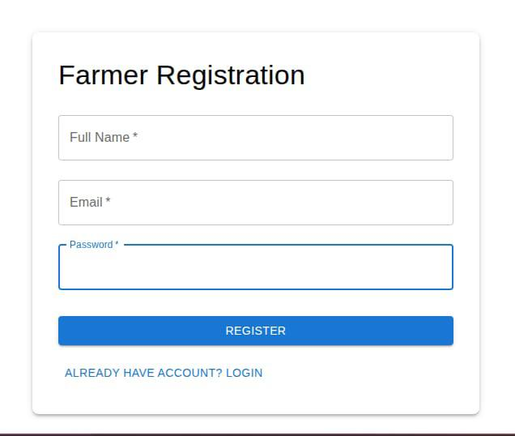
Fig B.1 Login Page

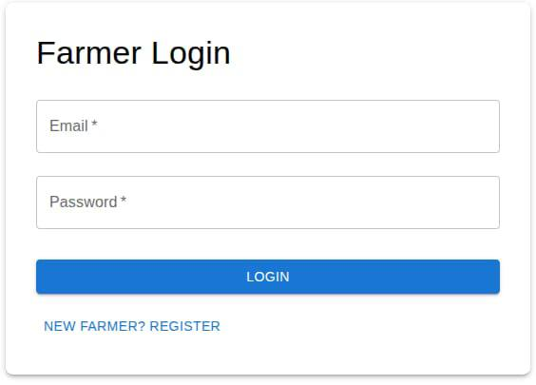
Fig B.2 Farmer Login Page

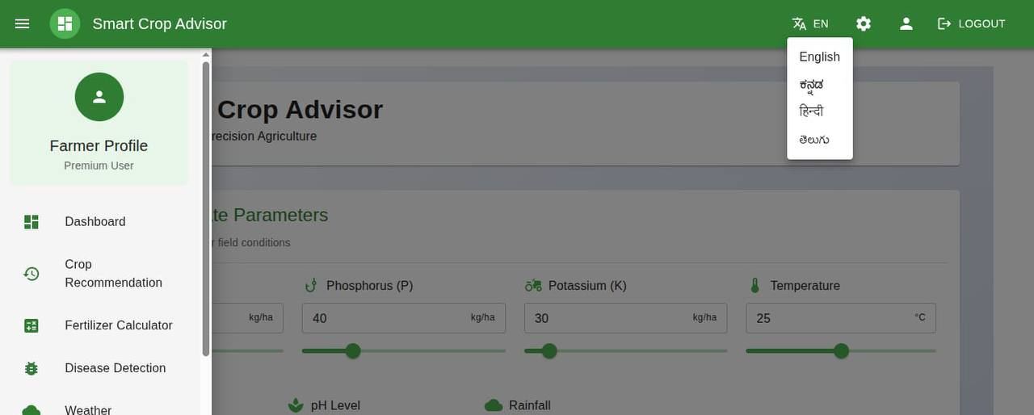
Fig B.3 Dashboard

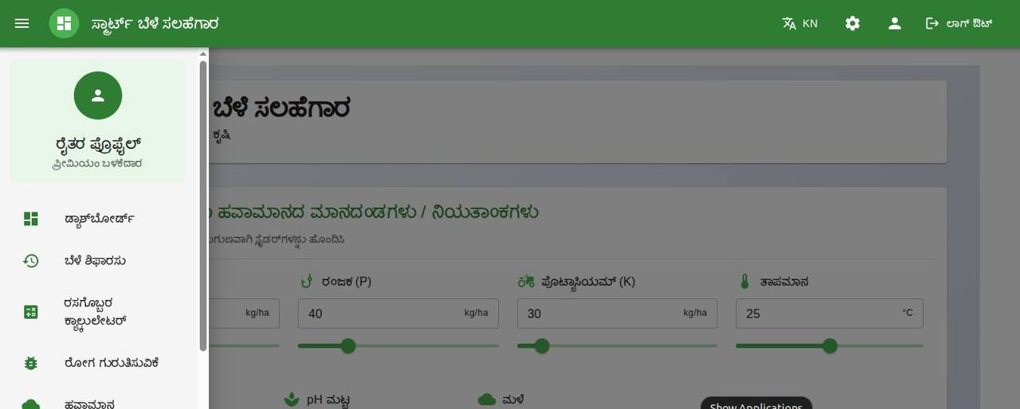
Fig B.4 Admin Video Lectures

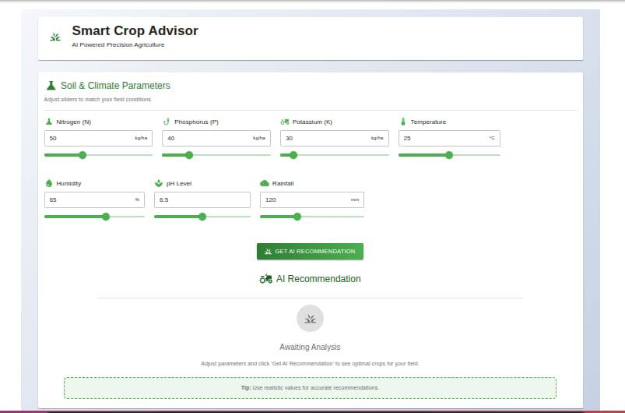
Fig B.5 Parental Report

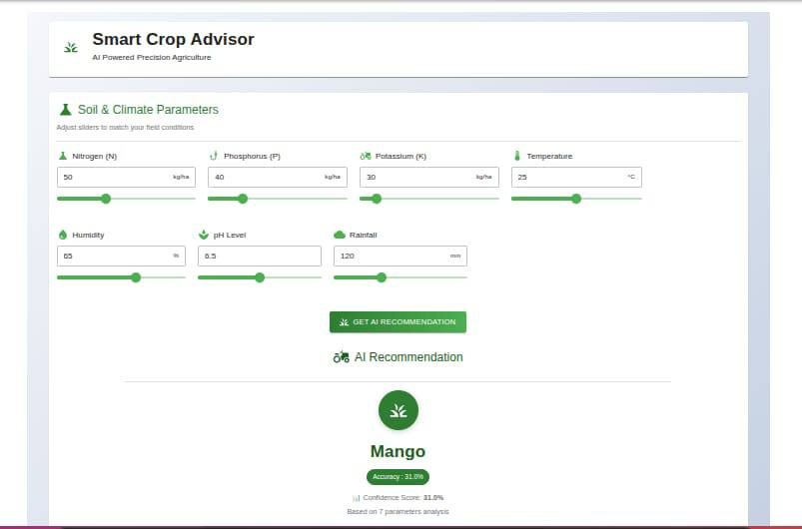
Fig

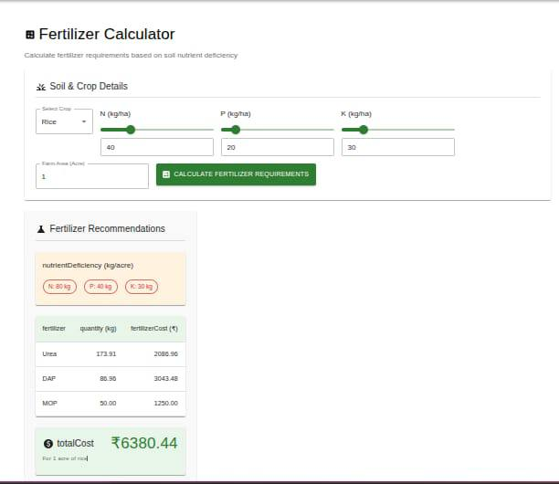

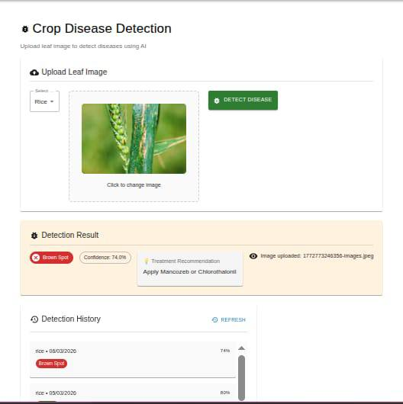
Fig
Fig

Appendix C : Code Snippets
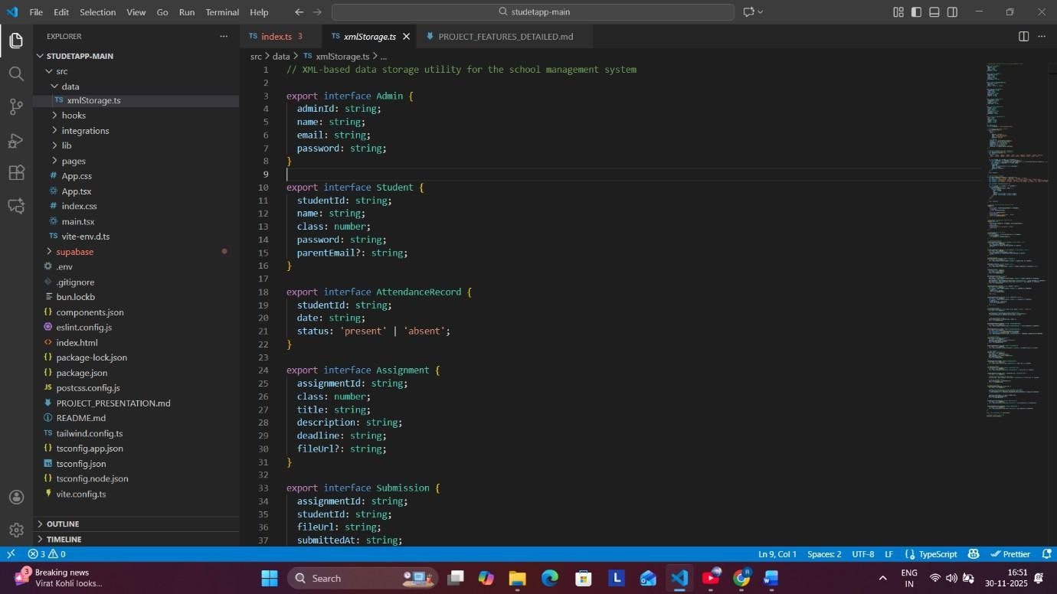
Fig C.1 XML Storage Layer (Data Persistence System)

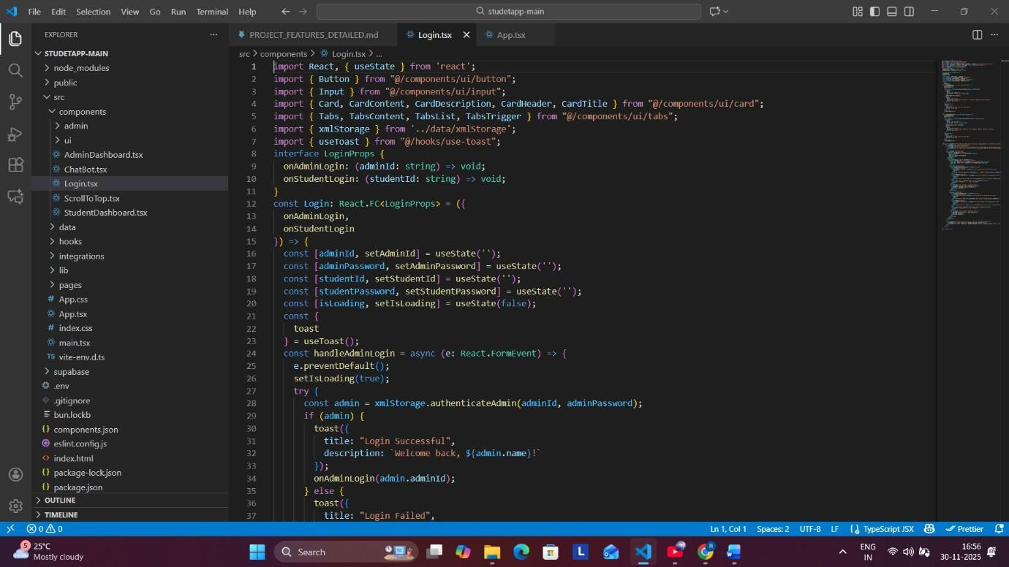
Fig C.2 : Dual Authentication System
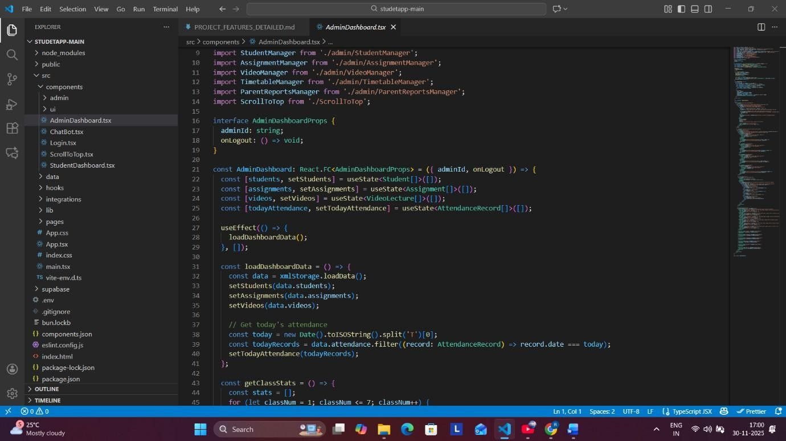
Fig C.3 Admin Dashboard Code (Management Hub)

Appendix D : GitHub Repository
GitHub Link : https://github.com/ShashidharReddyD/4th_Year_Major_Project
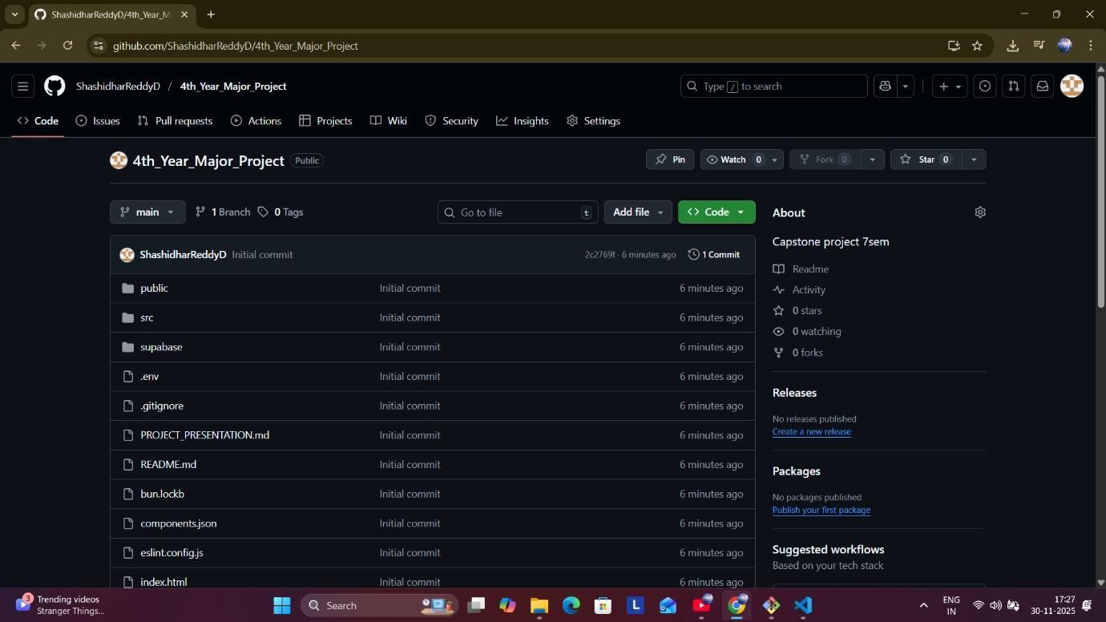
Fig D.1 GitHub Repository

Appendix E : Similarity And AI Report
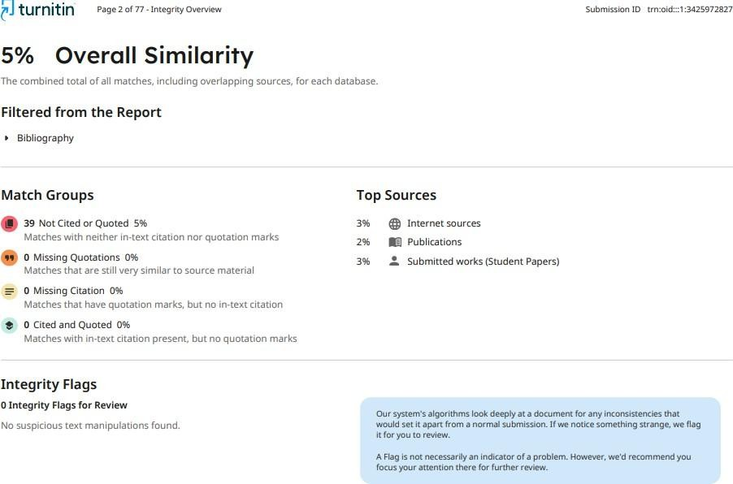
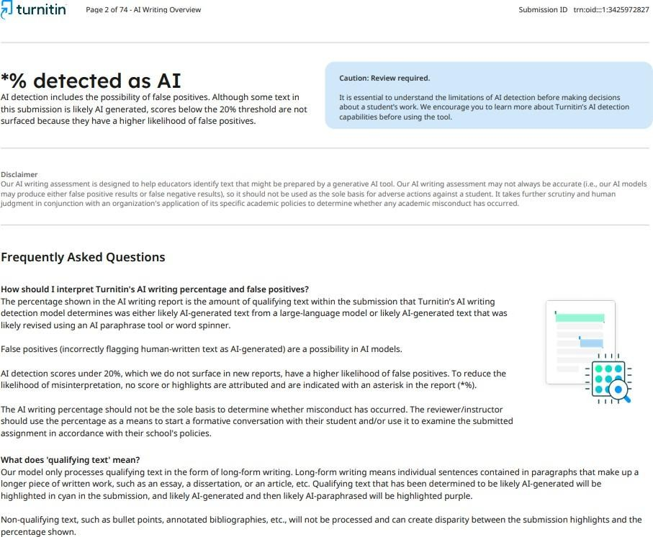
Fig E.1 : Report Similarity

Fig E.2 : AI Report

